2.7.20 Work to support your child at home
Maths
Today we are going to think about giving directions.
We can pretend to be robots in the garden giving the command to take steps forwards, backwards, to the left and to the right.

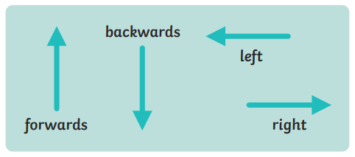

When using these instructions your body is facing the same way.
Start at the dark blue square on the treasure map. Follow these directions and see where you end up.

- Sidestep to your right 2 squares.
- Move up 2 squares.
- Sidestep to your left 2 squares.
- Move up 2 squares.
- Side step to your left one square.
- Move backwards one square.
- What are you standing on?

Is there a quicker route to get to the same square?

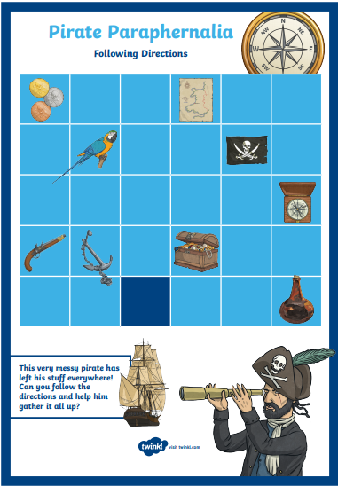
We can also give directions in a different way. We can tell people to turn their bodies to face a different direction before walking forwards.

We use the following words and they are linked to clocks.

a quarter turn a half tern
3 quarters turn a full turn
clockwise anticlockwise.

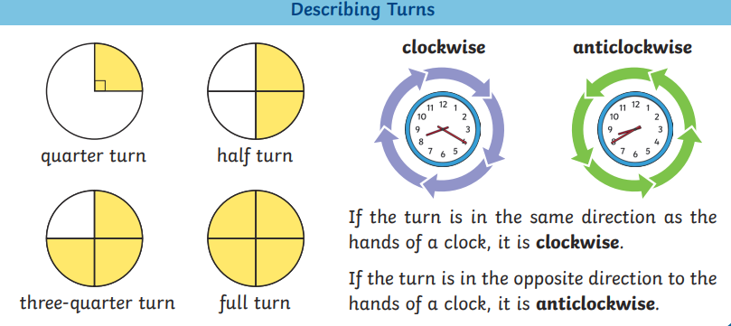

For today we are going to always turn in a clockwise direction. The best way to practise this is with your bodies like in this Super Movers video.
https://www.bbc.co.uk/teach/supermovers/ks1-maths-collection/z6v4scw
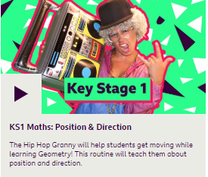
You can also turn objects around like the numicon piece below.

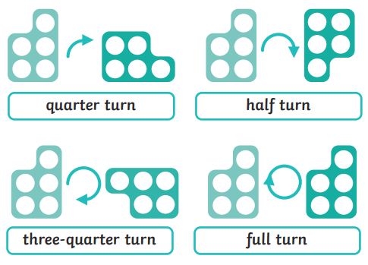

Can you find a toy car or a teddy bear?

Can you turn it a quarter turn clockwise?
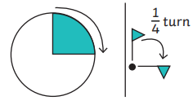
Draw what it looks like now.

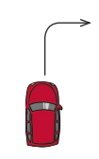

Start with it facing forward again and can you make it do a half turn clockwise?
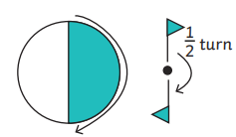
What happens if you do a half turn anticlockwise? Draw what it looks like.

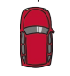

Now put the car back in the starting position. Can you make it do a 3 quarter turns clockwise?
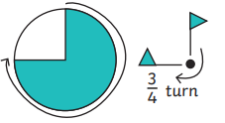
Draw what it looks like.

Have a look at the question below and talk about your answers.

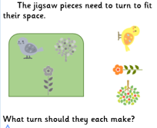

RED HOT CHALLENGE

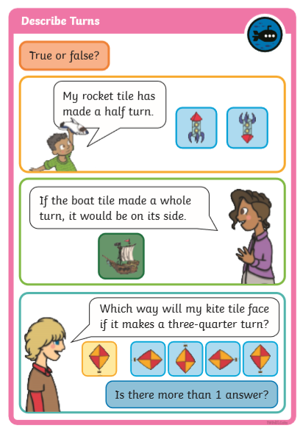

ENGLISH - Thursday 2.7.2020
This week we have been learning how to write a letter.
Today is the day to write your letter. We are writing them today so that we can help you to send your letters tomorrow! Tomorrow, we will show you different ways to send your letter. You can take a photograph of your letter and email it to us or post it onto Twitter. Or you can send your letter to us at school.
Have a go and enjoy yourself! You can even type your letter on the computer if that is easier for you.
If you want to send your letter to us, you can use paper that you have at home or you can download a free template from Twinkl to help you: https://www.twinkl.co.uk/resource/t-m-278-letter-writing-template
If you want to send us a photograph of your letter, you can write your letter in your home learning book as normal.
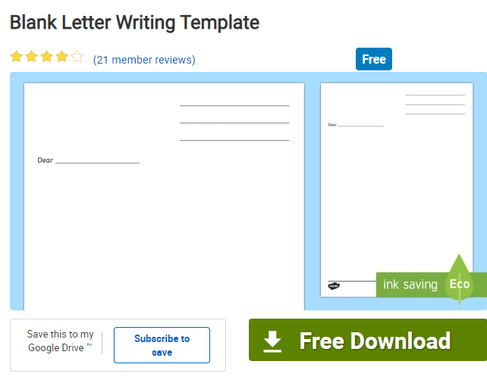

Main task:
*Use your plan from Tuesday to help you.
*Remember to include the date, who you are writing to, and who the letter is from.
* 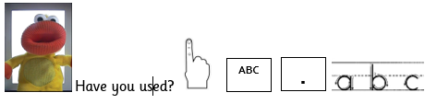
Who knows this book? It is my favourite book! It is filled with letters, and may give you more ideas if you are getting stuck: https://www.youtube.com/watch?v=gpeo_0yoD0k
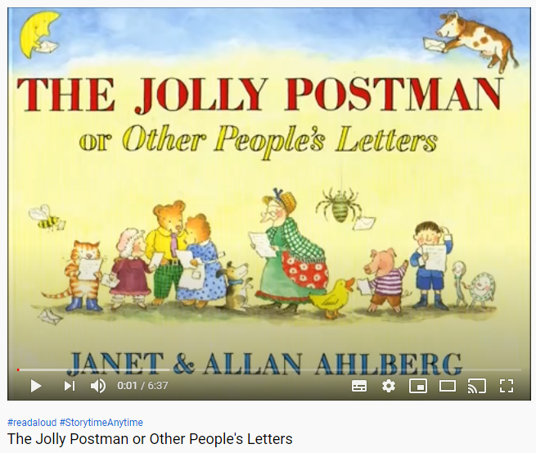

Phonics
Have a spelling competition using the words you have learnt this week. How many words can you think of that are contraction words?
How many words can you spell?
Time yourself, how many words can you write in 1minute?
Watch this You tube video. Remember to check with a grown up.
https://www.youtube.com/watch?v=gubPH3WEurg

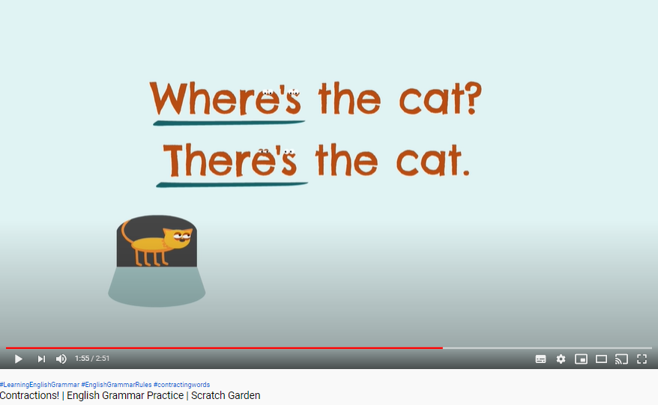

Look at these sentences. Can you spot the compound words? Write them down and underline the compound word like we do when we are at school.

My mum said I’ll need to water the sunflower.

My uncle’s a fireman.

‘Did you know she’s going to be 6 next week?’

I’d love to make snowmen in the winter.

It isn’t hot enough to put shorts on today.

Do you think he doesn’t like the cake?

On Wednesday the gardener saw a big beehive, it wasn’t full of bees.

There are some good tips on the game below for how to spell the days of the week.
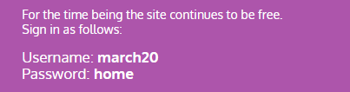
https://www.phonicsplay.co.uk/resources/phase/5/days-of-the-week

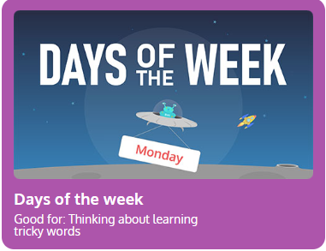

Topic- Geography
Today you will be drawing a map. You can choose to draw the map from home to school or from home to Smethwick High Street. You could even do it from your classroom to the field or another place in school.

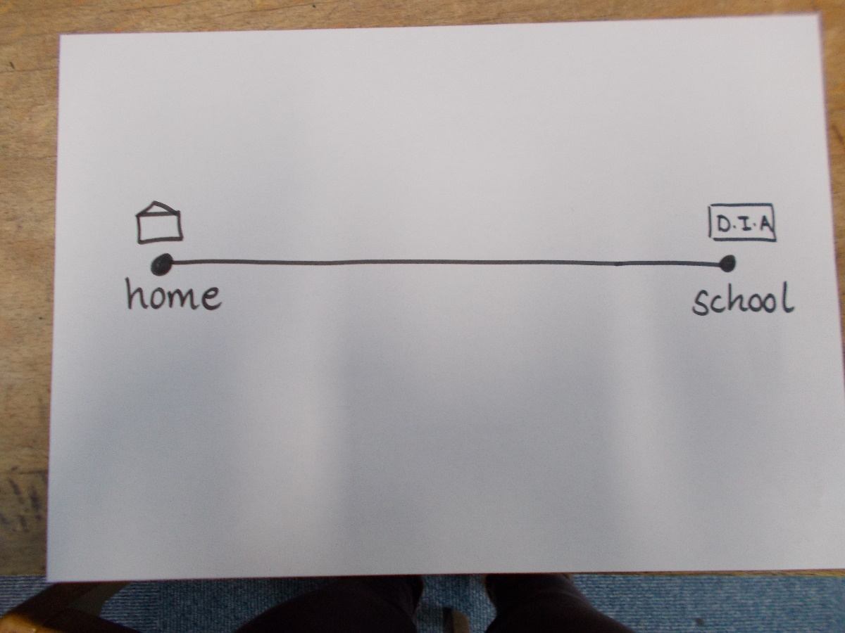

I have done mine from home to school. You choose where your starting point and end point will be.
You will need to draw and label the places you pass on the way.

Challenge

Use google maps to find your house and school, you can direct yourself using the arrows.
Remember to do it with a grown up.

https://www.google.com/maps/@52.4937946,-1.9824348,17z

