Reception Home Learning
Week 9
Day 1

A big smile from all your Early Years Teachers!
If you want to share any of the busy things you are doing at home with your Teachers, be sure to tag us on Twitter by using: @pinkclass18 and @devrainbow and @redclassdev

Monday 01st June 2020
Reception Work to support your child at home PHONICS
Below are some examples of how you can support your child at home with their phonics knowledge. We have set this out into daily activities.
Children learn best with daily practise and by repeating the learning.
You will need your phonic cards that were sent home in your pencil case.

Day 1 – Recap on sounds we have learnt before – (car, start, dark, card, sharp, bark, arm, park, market)

Learn the new sounds – or (for, fork, cord, port, born, horn, fort, storm, short, thorn, porch, torch, cor/net)

Practise the tricky word – one (also practise words we have learnt before –
(they, I, me, to, you, go, he, she, her, we, are, all, said, when, do, some. so)
What does each word mean? Do you notice any patterns? (write a list to show which words have the or sound at the beginning, middle and end).
Read one of the Bug Club or favourite books and write some of the tricky words you find. Tell a grown up what happened in the book and what was your favourite part.
Alphablocks is a great website to support with phonics and with how to pronounce the sounds
https://www.bbc.co.uk/bitesize/topics/zvq9bdm/articles/z4tyt39
https://www.thenational.academy/
https://www.bbc.co.uk/cbeebies/shows/alphablocks
https://new.phonicsplay.co.uk/
You can log into phonics play for free using:
Username: march20
Password: home

Don’t forget you can also access active learning using your school password found in your home work diary to continue home reading. https://www.activelearnprimary.co.uk It also has some new activities for other areas of learning.

Monday 1st June 2020
Work to support your child at home- LITERACY
Day 1-
This week we are going to focus on the story ‘The Town Mouse and the Country Mouse’. You can find the story by following this link: https://www.youtube.com/watch?v=BNexgokr4gw
This week’s sentences to learn are:
One cold night, a mouse heard a knock at the door. It was his friend Tony the town mouse. They decided to visit the busy town to get some food.

Today, your talking task is to:
- Practise saying the sentences- Put your actions to the sentences above as we do in class. Act out the sentences.
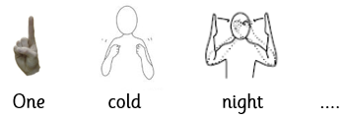
For example:

- Once you have practised saying the sentences together, see if your child can now remember the sentences and say them without your support. If they can, it means they are ready to write them tomorrow!

Monday 1st June 2020
Reception Work to support your child at home MATHS numbers
This week Is a recap for your children. Some of them will feel confident to do this but it is important to recap as we have not cover number this term. We are looking at ordering, recognising and missing numbers to 20.
This week we are looking at numbers to 20
Watch and sing the https://www.youtube.com/watch?v=D0Ajq682yrA

Can you recite numbers from 0 to 20 and then back to 0 to your grown up?

Challenge Oh dear these numbers are all messed up can you put the numbers in the correct order?
0 | 1 | 5 | 4 | 3 | 2 | 6 | 9 | 7 | 8 | 10
11 | 15 | 13 | 14 | 12 | 19 | 17 | 18 | 16 | 20 | ?

Check have you got all your numbers facing the correct way? Ask your grown up to check. If you have some that are not correct, have a go at writing these again.

Can you find the correct amount of objects to match the number in each shape? Check with your grown up?
Can you count how many hops you can do? How many steps does it take you to walk around your living room? Can tell your grown up what number you live at?
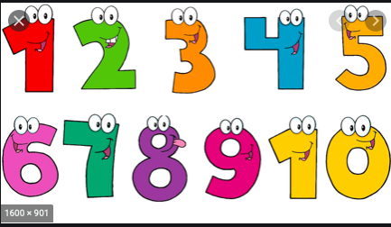

Free-flow- Town and Country- Town week
Talk to your grown-up:
Where do you live? Is it in a Town or in the Countryside? How do you know?
Use the pictures below to help you:
