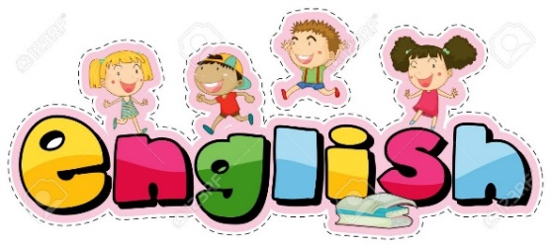

ENGLISH

Follow the link:
https://classroom.thenational.academy/lessons/the-firework-makers-daughter-to-retrieve-information-3a40c4
The teacher in the video goes over all of the work, including the answers.
This lesson is going to be about retrieving information from a text.
When retrieving information for a question, this is what you should do:

Work through the questions using this order to help them.

Maths -

Fractions -Warm up
Practising halves and doubles with a game (Double or halve? Or hit the button – halves to 10 or doubles to 10).
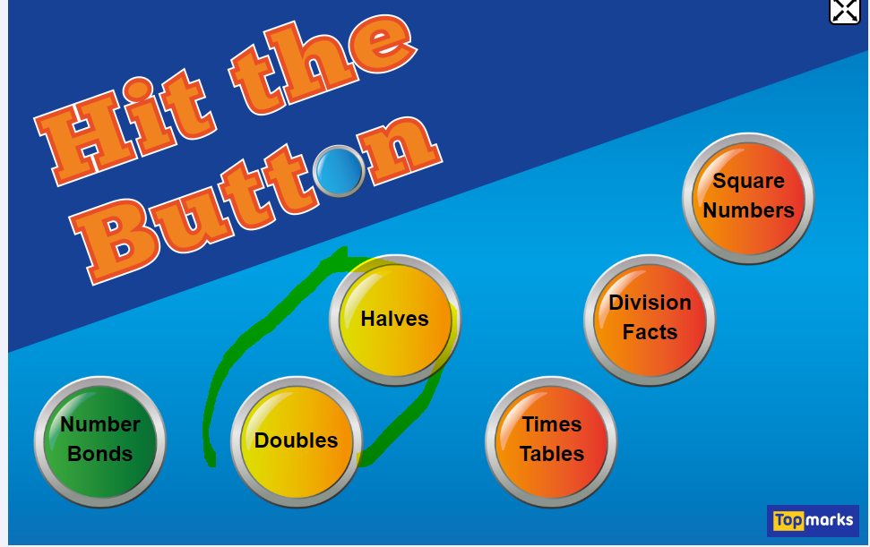
How to play ‘Double or halve?’:

A game dice or an interactive one here.
- Decide on a target number between 0 - 30. This is the total that both players are trying to make.
- Player 1 throws the dice. S/he can choose whether to double the number shown or halve the number shown.
- Player 2 throws the dice. In the same way, s/he can choose whether to double the number shown or halve the number shown. Player 2 adds his/her number onto Player 1's number to make a running total.
- Play continues like this with each player rolling the dice, halving or doubling the number and adding the result onto the running total.
- The winner is the player who reaches the nearest to the agreed target.
Target number 11

Rolled a… | double or half? | answer | Running total
3 | double | 6 | 6
6 | halve | 3 | 6 + 3 = 9
4 | halve | 2 | 6 +3 +2 =11

Have a go yourself.

Main – Can I find $\frac{1}{3}$ (one third) of a number?
Here is what one third looks like in fraction notation $\frac{1}{3}$
The denominator shows that the whole is split into ____ parts.
The numerator shows that one part is to be shown.
Can you shade in $\frac{1}{3}$ (one third) of these shapes?
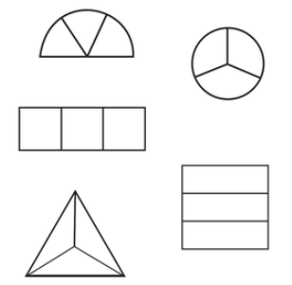
What about when there are more than 3 parts?
You’ll have to share out the whole number of parts by 3.
So a third of this rectangle is
Show that one third is shaded in 3 other ways.
So if we’re finding a third of an amount then we need to use these three parts to share equally between.
Question | Working out
- One third of 12 =

- $\frac{1}{3} of 9=$

- $\frac{1}{3} of 15=$

- One third of 18 =

- One third of 21 =

- $\frac{1}{3} of 6=$

- One third of 3 =

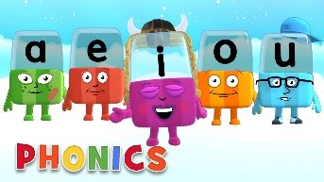
Phonics

Day 2 – Below are the sounds and words that you should know by the end of year 2.

The al sound spelt a before l and ll (all tall fall)
The /u/ sound spelt o (other, mother, brother)
The /o/ sound spelt a after w and qu (quantity, squash, want, watch)
The /ur/ sound spelt or after w (word, work, worm, world)
The /or/ sound spelt ar after w (war, warm, towards)
The /zh/ sound spelt s (treasure, television, pleasure, visual)
Words ending in –tion (station, vacation)
Adding –ed, –ing, –er and –est to a root word ending in –y with a consonant before it.
Adding the endings –ing, –ed, –er, –est and –y to words ending in –e with a consonant before it (hiking, hiked, hiker, nicer, nicest, shiny)
Adding –ing, –ed, –er, –est and –y to words of one syllable ending in a single consonant letter after a single vowel letter (doubling up)

Complete the activity below,

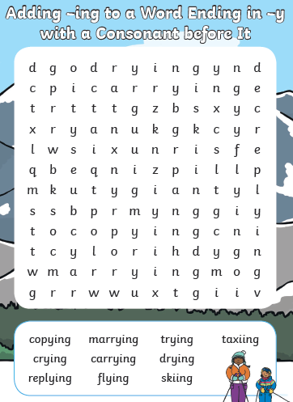
Look at your new homework on Education city, remember your password is at the front of your reading diary.
www.educationcity.com
Read your reading book out loud to your toys, don’t forget to use expression.

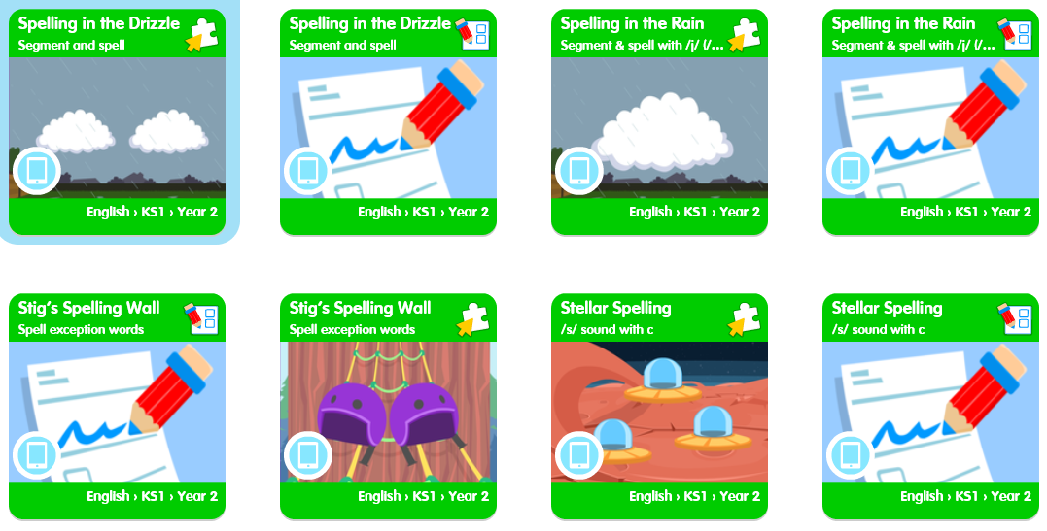

Topic - Day 2

There are 3 great web links to explore.
Check them out and remember to save your favourites to do again and again!
1.

#ThisIsPE
Description: videos delivered by teachers focussing on the PE curriculum which are accessible on YouTube. These have been commissioned by the Association for Physical Education
https://www.afpe.org.uk/physical-education/thisispe-supporting-parents-to-teach-pe-at-home/
Their YouTube link:
https://www.youtube.com/playlist?list=PLYGRaluWWTojV3An2WEgsQ4qGFy_91jDL
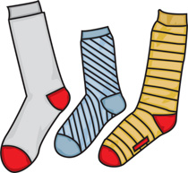
My favourite 2 are below and you will need:
Socks

Lots of energy

Strategic thinking (Thinking on your feet)

Teddy bears
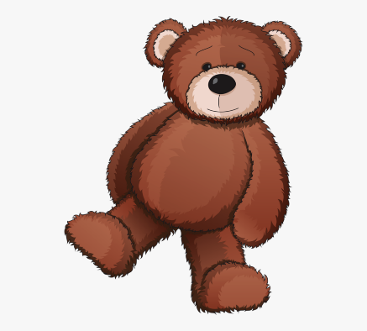

#ThisIsPE - Sock Wars
https://www.youtube.com/watch?v=TUA9CqMxI8k&list=PLYGRaluWWTojV3An2WEgsQ4qGFy_91jDL&index=16&t=0s

#ThisIsPE - Fast feet
https://www.youtube.com/watch?v=IaNjXnB-79U&list=PLYGRaluWWTojV3An2WEgsQ4qGFy_91jDL&index=10
2.

Active at Home
Description: The ACTIVE AT HOME programme allows children, parents, friends and family to look at some of our fun games that are used in school. You will have access to our lesson plans, videos and diagrams to help you keep active while you are not at school.
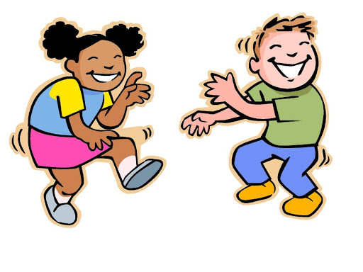
Not a very exciting web page visually but some cool dances!
https://online.succeedin.co.uk/public/index/638

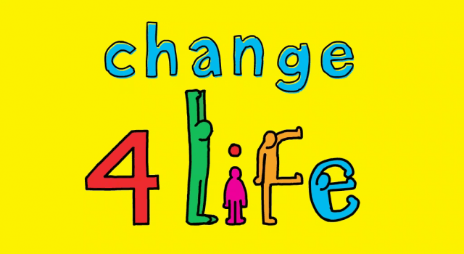
3.

NHS – Change 4 life

Description: This website shares a number of links and ideas for fun home based activities at home, many of which link with other curriculum areas.
https://www.nhs.uk/change4life/activities

