It has been lovely to see some of you tweeting your work on Twitter. Don’t forget to tag us, so we see your tweet!
https://twitter.com/DevonshireInf
@Devonshireinf @MrFlemingDevInf @devOrangeClass
@devcreamclass @MsSandhuDevInf
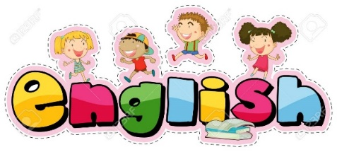

ENGLISH

Follow the link:
https://classroom.thenational.academy/lessons/to-write-a-recount/activities/1
Today, the children are going to be writing their own recount.
After the spelling test, they are going to be reading the passage from ‘The Firework maker’s Daughter’.

The Teacher has put this recount into 5 main events. These are going to help you write your own recount.
In order to help you with writing the recount, here are some star words that you can use.
You are going to work with the teacher on the video to write the first part of the recount together, then continue it on your own.

Remember, when writing you need to think about capital letters, full stops, spellings, and making sure your writing makes sense.
Once you are done, reread your work to check it.
Once that is done, read it to someone and see what they think!

Maths – Money
Warm up
Match the hands to the same amount shown in the purses.
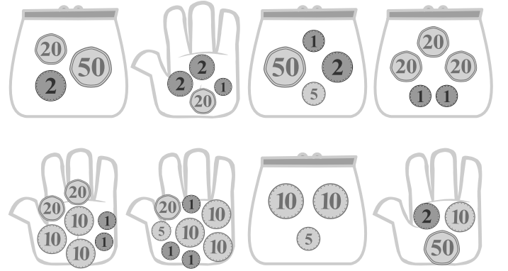
Have a go at some of the education city activities on using your login.
The new homework city is called Summer Money
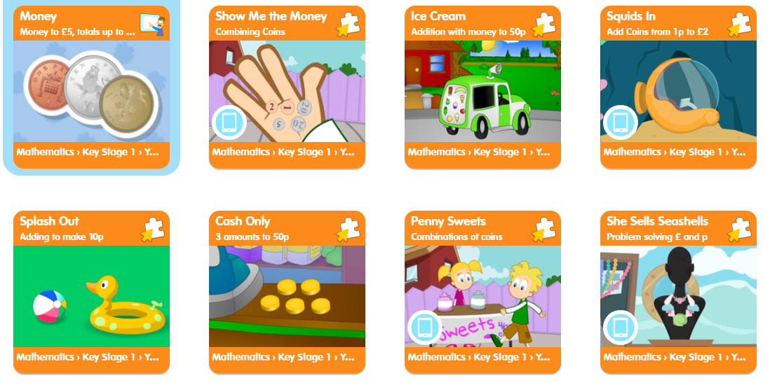

Can you tick the right coins to make the amount?
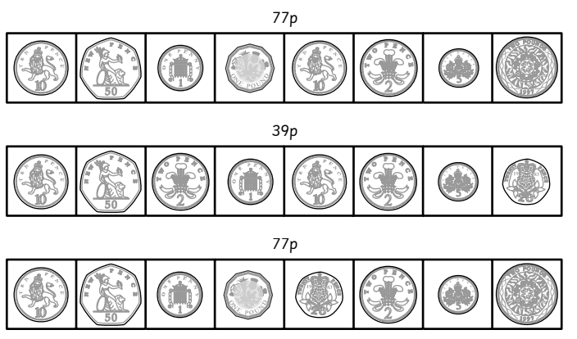
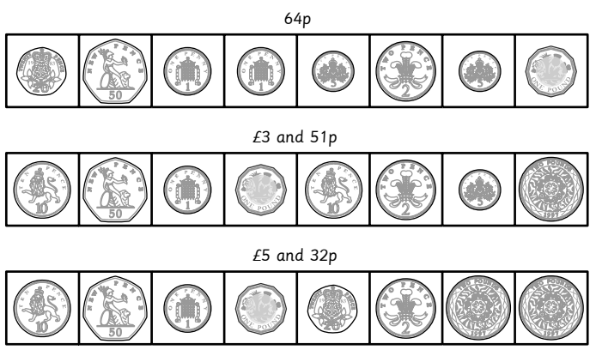

Can you work out these amounts?
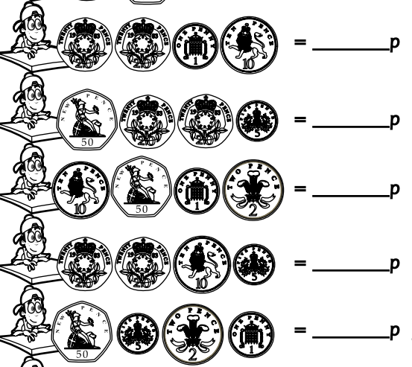

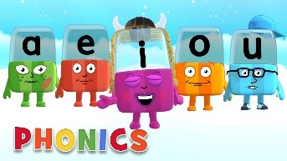
Phonics

Day 5 – Below are the sounds and words that you should know by the end of year 2.

The /j/ sound spelt as ge and dge at the end of words, and sometimes spelt as g elsewhere in words before e, i and y (badge, edge, bridge, dodge, fudge)
The /s/ sound spelt c before e, i and y (race, ice, cell, city, fancy)
The /n/ sound spelt kn and (less often) gn at the beginning of words (knock, know, knee, gnat, gnaw),
The wr sound spelt wr at the beginning of words (write, written, wrap, wrote)
The /l/ or /le/ sound spelt –le at the end of words (table, apple, bottle, little)
The /al/ sound spelt –al at the end of words (metal, pedal, capital, hospital)
The /l/ or el/ sound spelt –el at the end of words (camel, tunnel, squirrel)
Words ending –il (pencil, fossil, nostril)
The /igh/ sound spelt –y at the end of words (cry, fly, dry)

Complete this activity below,

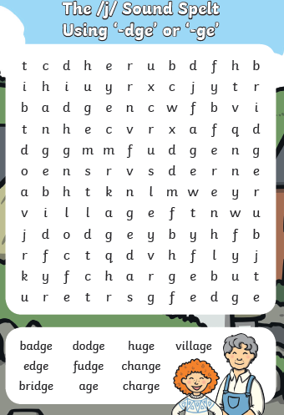
Have a spelling competition using the words you have learnt this week
Then practise reading and spelling 10 common exception words. This can be found on https://spellingframe.co.uk/
Read your reading book – Ask your grown up some questions about your book. Why did the character behave like that? What do you think will happen next?
Write an alternative ending to your book.
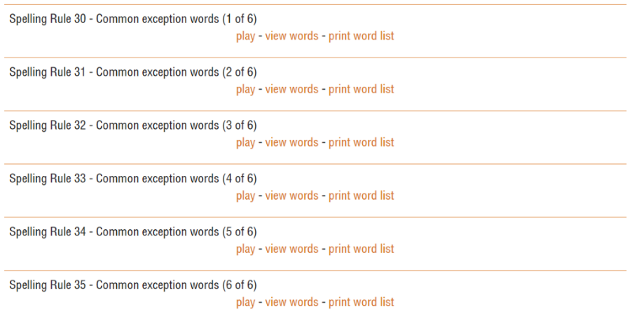
Alphablocks is a great website to support with phonics and with how to pronounce the sounds
https://www.bbc.co.uk/cbeebies/shows/alphablocks
Phonics Play has a range of phonics resources and games
www.phonicsplay.co.uk
Spelling frame has lots of games to practice Year 1 and 2 sounds and common exception words.
https://spellingframe.co.uk/
Education City has games and activities for phonics, some may be set or you can choose your own. After an activity you can print your own certificate too.
www.educationcity.com

Topic - Day 5

Here are some crafty ideas - try 1 or 2 for some messy fun!

Playdough recipe and video link
Makes 1 coloured ball
Prep 10 minutes
You will need
- 8 tbsp plain flour
- 2 tbsp table salt
- 60ml warm water
- food colouring
- 1 tbsp vegetable oil
Method
1. Mix the flour and salt in a large bowl. In a separate bowl mix together the water, a few drops of food colouring and the oil.
2. Pour the coloured water into the flour mix and bring together with a spoon.
3. Dust a work surface with a little flour and turn out the dough. Knead together for a few minutes to form a smooth, pliable dough. If you want a more intense colour you can work in a few extra drops of food colouring.
4. Store in a plastic sandwich bag (squeeze out the air) in the fridge to keep it fresh

https://www.bbcgoodfood.com/howto/guide/playdough-recipe

How to make paper mache (papier-mâché)
Papier-mâché, or is the perfect activity for kids. Here is a step-by-step guide and a video too.
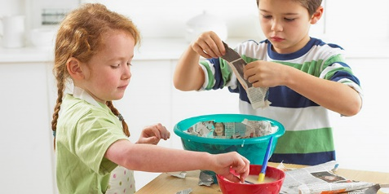

Makes 1 big batch
Prep 10 minutes
- An old newspaper, comics or magazines
- 1 level mug of plain flour
- 1 level mug of warm water, plus extra tap water for loosening
Method
1. Tear or cut strips or little squares from your newspaper, comics or magazines according to the project you're working on. Do this first before you make the paste so that the paste doesn’t set while you’re cutting paper.
2. Stir together the flour and warm water in a large mixing bowl until well combined. Add extra tap water a little at a time to loosen. You want a smooth, batter-like paste with no lumps. You can sift the flour first for a super smooth finish.
3. Cover your work area in more old newspaper. Dip the paper strips in the paste, wipe off the excess on the side of the bowl and stick onto your project. Use a paintbrush to smooth down the paper and remove any air bubbles or excess paste. Repeat to cover and leave to dry before adding further layers. In our video we made a comic-covered tin to use as a pot for storing kids’ cutlery and covered a balloon to paint and turn into a face, globe – or anything else you dream up

https://www.bbcgoodfood.com/howto/guide/how-make-paper-mache

How to make bubble mixture
Learn how to make your own homemade bubble and find ideas for making your own bubble wands.

Bubble mixture
Makes 350ml
Prep 5 minutes
- 50ml washing-up liquid (one part)
- 300ml water (six parts)
1. Measure the washing-up liquid into a container, such as a jam jar or glass bottle.
2. Slowly add in the water, being careful not to create too many bubbles at this stage. Gently stir the mixture together to combine – a chopstick is perfect for this.
3. If you can, let the bubble mixture rest before using it, as it will make your bubbles even better.
4. When you’re ready, dip your bubble wand into the mixture and start blowing bubbles!

Homemade bubble wands
If you don’t have a wand from a store-bought pot of bubbles, don’t despair! You can have fun by looking for different items around the house that can be used to make bubbles. Here are some ideas to get you started:
- Paperclips – bend them into wands or use as they are
- Straws
- Biscuit cutters
- Pipe cleaners
- Fly swatters

Top tips
Glycerine can be found in the baking section of most major supermarkets and can be added to the bubble mixture to make it more stable. We found that adding 1 tbsp glycerine to the recipe above made our bubbles last much longer.
Letting it rest overnight, or as long as you can bear to wait, does allow the mixture to settle and combine, which will improve your bubbles.
Think big – if you want to scale up the recipe, you just need one part washing-up liquid to six parts water. Try making a big bubble mixture in a washing-up bowl – then you can use bigger items, like colanders and slotted spoons, to make bubbles in the garden

