Reception Home Learning
Week 9
Day 3

A big smile from all your Early Years Teachers!
If you want to share any of the busy things you are doing at home with your Teachers, be sure to tag us on Twitter by using: @pinkclass18 and @devrainbow and @redclassdev
Stinkerbell.

Joke What do you call a fairy that doesn’t like to shower?

Wednesday 3rd June 2020

Reception Work to support your child at home PHONICS
Below are some examples of how you can support your child at home with their phonics knowledge.
Children learn best with daily practise and by repeating the learning.
Below are some examples of how you can support your child at home with their phonics knowledge.
Children learn best with daily practise and by repeating the learning.
Day 3 –Read each sentence below, find the or sound in each sentence and write the words with these sounds. How many words did you find? Can you write your own sentences using the same words.

Challenge yourself to think of some different words with this sound and have a go at writing them or clap them to your grown up.
For example – horn would be three claps for the sounds you say h or n

I can see in the dark with a torch.

The thorn is long and sharp.

The car had a big, red horn.

I like to eat an ice cream from a cornet.

The fork is on the picnic table.

It is a short walk to the school.
Read your reading book or a favourite book from home and see if you can find any or words. Did you find any tricky words?
Alphablocks is a great website to support with phonics and with how to pronounce the sounds
https://www.bbc.co.uk/cbeebies/shows/alphablocks
https://new.phonicsplay.co.uk/ You can log into phonics play for free using: Username: march20 Password: home

Wednesday 3rd June 2020
Work to support your child at home- LITERACY
This week we are focusing on the story ‘The Town Mouse and the Country Mouse’. You can find the story by following this link: https://www.youtube.com/watch?v=BNexgokr4gw
- Yesterday you wrote our ‘we do’ sentences about the story.
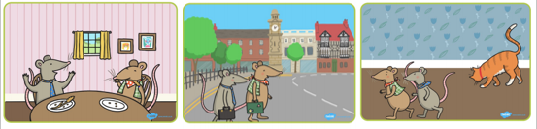
- Today can you write your own sentences about the pictures from the story?

Wednesday 3rd June 2020
Reception Work to support your child at home MATHS- number
Oh dear, some of the number are missing. Can you fill in the missing numbers and then read them out loud to your grown up to make sure they are right?

Use your Numicon shapes to make some of the numbers above. Can you see any patterns in your numbers?
Use different pieces of numicon to make a number up to 20?
Challenge- Can you mane number 13, 15, 19, 20 and 22?

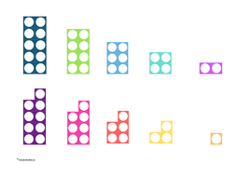 = 12

Free-flow- Town and Country- Town week
Yesterday you talked about how to travel safely around Town.
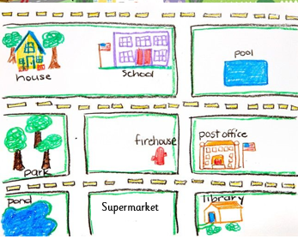
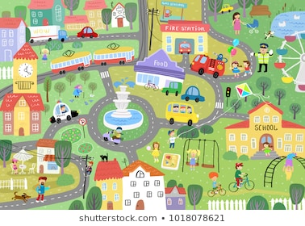
Today, can you create a map/picture of your Town?

