

It has been lovely to see some of you tweeting your work on Twitter. Don’t forget to tag us, so we see your tweet!

<https://twitter.com/DevonshireInf>

@Devonshireinf @MrFlemingDevInf @devOrangeClass

@devcreamclass @MsSandhuDevInf

**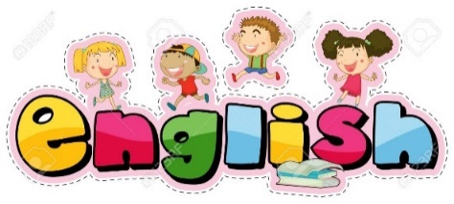**

**ENGLISH**

Follow the link:

<https://classroom.thenational.academy/lessons/to-identify-and-use-different-sentence-types/activities/1>

Today you are going to be looking at different sentence types.

There are 3 here: a statement, question and an exclamation

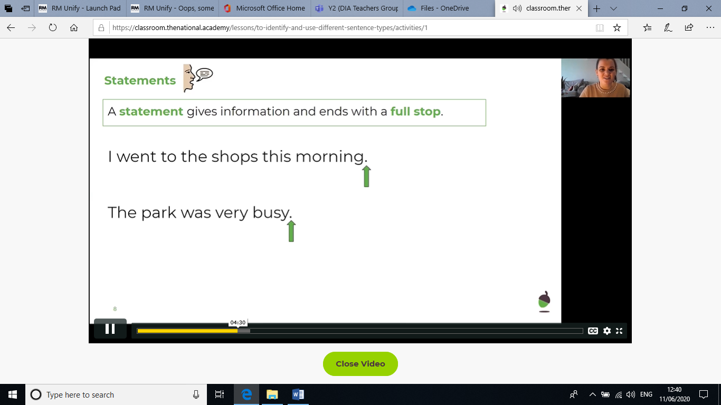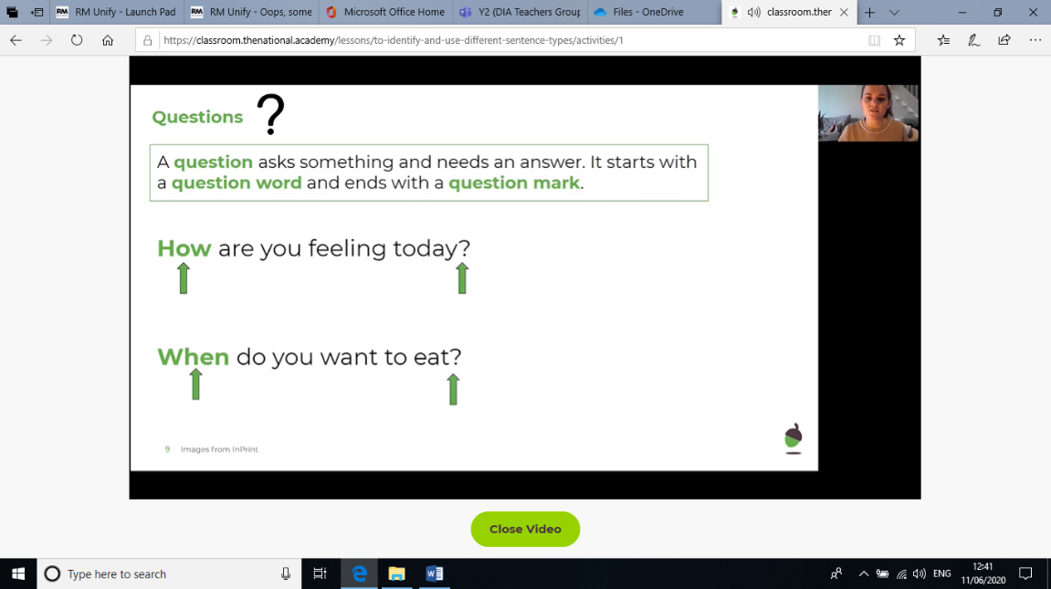

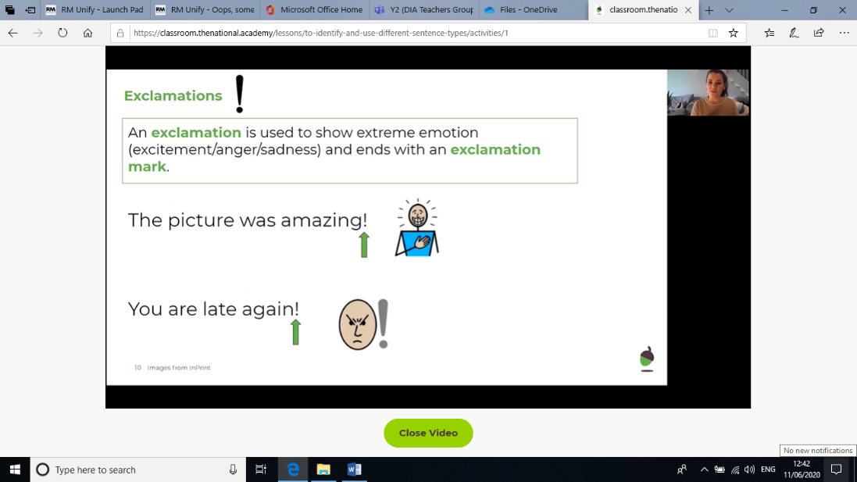

Work through the questions.

The first part is about identifying what each sentence is, whether it is a statement, a question or exclamation.

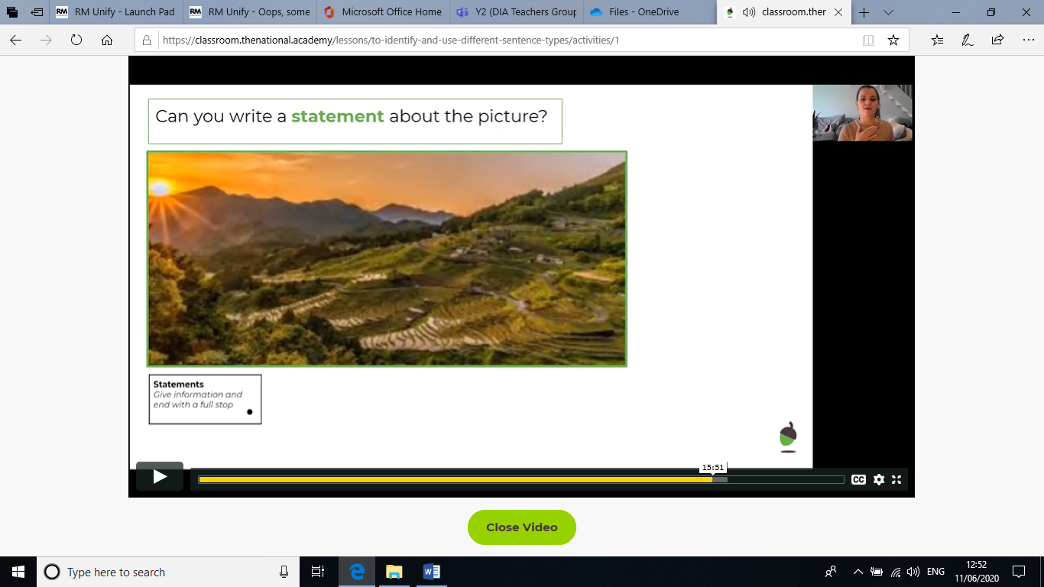The next part is writing your own sentences.

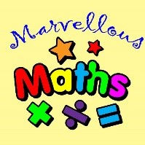

**Maths – Money**

Warm up - Number bonds to subtract from 100

By now, your number bonds to 10 should be fairly straight forward to remember. (after all, you do have 10 fingers).

What if those number bonds all represented tens?   
So instead of 1+9= 10 it was

1ten +9ten = 10tens That means 10 + 90 = 100

This is how we can quickly write addition and subtraction sentences that make 100.

|  |  |
| --- | --- |
| Addition + | Subtraction - |
| 10 + 90 = 100 | 100 - 90 = 10 |
| \_\_\_ + \_\_\_ = 100 | 100 - \_\_\_ = \_\_\_ |
| \_\_\_ + \_\_\_ = 100 | 100 - \_\_\_ = \_\_\_ |
| \_\_\_ + \_\_\_ = 100 | 100 - \_\_\_ = \_\_\_ |
| \_\_\_ + \_\_\_ = 100 | 100 - \_\_\_ = \_\_\_ |
| \_\_\_ + \_\_\_ = 100 | 100 - \_\_\_ = \_\_\_ |
| \_\_\_ + \_\_\_ = 100 | 100 - \_\_\_ = \_\_\_ |
| \_\_\_ + \_\_\_ = 100 | 100 - \_\_\_ = \_\_\_ |
| \_\_\_ + \_\_\_ = 100 | 100 - \_\_\_ = \_\_\_ |
| \_\_\_ + \_\_\_ = 100 | 100 - \_\_\_ = \_\_\_ |

**Can I find the change from amounts up to £1?**

FINDING CHANGE MAIN LESSON.

When we go to pay at the shop, 2 things happen at the till.

The shopkeeper has to add up how much everything costs.

We have to pay for it.

Sometimes we don’t have exactly the right money, so we can pay with more and are given back our **change.** The shopkeeper doesn’t get to keep the extra money that you gave them. They take what you owe them and you get the rest back. This way you can look at it like your money being reduced.

**Your items £18**

This much will be your change

**you pay with a £20 note**

Drawing this diagram helps me to represent the maths that is happening.

So now I can see that I need to count between 18 and 20 to know how much I should get in change.

1. I could start on 18 and count on using number bonds knowing 18 + **2** = 20
2. I could start on 20 and count back until I reach 18. 20, **19, 18 two jumps.**
3. I could start on 18 and count on until I reach 20**.** 18 **19 20 two jumps again.**

|  |  |  |  |  |  |  |  |  |  |  |  |  |
| --- | --- | --- | --- | --- | --- | --- | --- | --- | --- | --- | --- | --- |
| +2   |  |  |  |  | | --- | --- | --- | --- | | 18 |  |  | 20 | | **-1 -1**   |  |  |  | | --- | --- | --- | | 18 | 19 | 20 | | **+1 +1**   |  |  |  | | --- | --- | --- | | 18 | 19 | 20 | |

**Either method lets me see that I need £2 back in change.**

**Remember:  
You’ll need to do penny jumps and pound jumps for some count between sentences.**

Here are the items at a shop

|  |  |  |
| --- | --- | --- |
| **Cost of item** | **Amount paid** | **Change** |
| £8MCj03985470000[1] | £10 |  |
| £5MCHM00154_0000[1] | £20 |  |
| £27MCj01108730000[1] | £50 |  |
| £7MCSL00704_0000[1] | £20 |  |
| £6 MCj02327240000[1] | £20 |  |

Use one of the strategies above for each question

Challenge: try a different strategy and see if you can get the same amount of change.

Do you have a favourite strategy?

**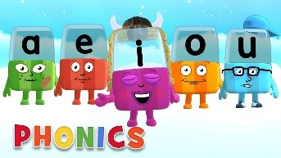Phonics**

|  |
| --- |
| Day 3 – Below are the sounds and words that you should know by the end of year 2.  The /j/ sound spelt as ge and dge at the end of words, and sometimes spelt as g elsewhere in words before e, i and y (badge, edge, bridge, dodge, fudge)  The /s/ sound spelt c before e, i and y (race, ice, cell, city, fancy)  The /n/ sound spelt kn and (less often) gn at the beginning of words (knock, know, knee, gnat, gnaw),  The wr sound spelt wr at the beginning of words (write, written, wrap, wrote)  The /l/ or /le/ sound spelt –le at the end of words (table, apple, bottle, little)  The /al/ sound spelt –al at the end of words (metal, pedal, capital, hospital)  The /l/ or el/ sound spelt –el at the end of words (camel, tunnel, squirrel)  Words ending –il (pencil, fossil, nostril)  The /igh/ sound spelt –y at the end of words (cry, fly, dry)  Complete this activity below, |
| Practise reading and finding the meanings of the words. Can you find any other words with the un or dis prefix? |
| 1. Follow this link;   <https://www.spellzone.com/curriculum/national-curriculum/year-2.cfm>   1. Then choose the sound you wish to learn from the orange block, scroll down for more. 2. Then select “[**Spellzone course word list**](https://www.spellzone.com/word_lists/list-71.htm)”   Step 2  Step 3   1. You can select the words you wish to hear or an activity from the top     Choose an activity  Or  Hear the words to practise spelling them. |
| Read a reading book from Bug Club, remember your password is in front of your diary. |

Alphablocks is a great website to support with phonics and with how to pronounce the sounds

<https://www.bbc.co.uk/cbeebies/shows/alphablocks>

Phonics Play has a range of phonics resources and games

[www.phonicsplay.co.uk](http://www.phonicsplay.co.uk/)

Spelling frame has lots of games to practice Year 1 and 2 sounds and common exception words.

<https://spellingframe.co.uk/>

Education City has games and activities for phonics, some may be set or you can choose your own. After an activity you can print your own certificate too.

[www.educationcity.com](http://www.educationcity.com/)

**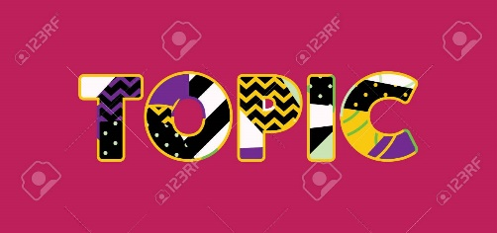Topic** Day 3

Contour Drawing is all about LOOKING and NOTICING little details so you draw by observing.

1.My favourite is the **blind contour drawing.**

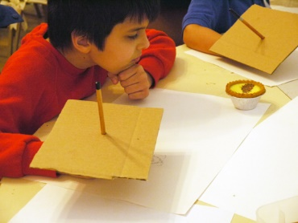

Get a piece of card and get an adult to push your pencil through. This will hide your view of your drawing and help you focus on the object you are drawing. It is important to look carefully when you are drawing.

Choose a simple object to draw.

## WHAT SHOULD WE DRAW…?

A contour line drawing can be of anything.  There are no limitations to what you “could” draw.  But as this is a blind contour drawing exercise, it is a lesson meant for children and meant to be done in a matter of minutes, think simple. A single flower, a piece of fruit, a leaf, a favourite stuffed animal- would all make excellent subjects.

Drawing something that you are super familiar with and looking at it in a new light is always fun!

This is harder than it sounds because it is so tempting to look at what you’re drawing.  A blind contour drawing may look a **little weird.** In fact, if it doesn’t, you probably cheated and looked at your paper!  **You will giggle!**

I love blind contour drawings for this reason. The pressure to make your drawing look “just right” is totally gone.  **After all, you can’t even see your drawing!**  You have to concentrate on really looking at the object and noticing all the detail. Pick a simple object and try to really notice each little edge and part. No more drawing what you “think” you know about flowers. (Or whatever you’re drawing.)

## DRAW IT AGAIN & AGAIN…

Each contour line drawing that you do will take no more than a couple of minutes.  Try to work slowly **don’t worry about mistakes**.  Just keep going.  Since these drawing exercises are so short try **drawing the same object from different angles**.

**2**. **A Continuous Contour**

A**continuous contour line drawing** focuses on keeping your marker on the paper and slowly moving from one contour onto the next.  **The line just keeps moving, crossing over itself, and back around without picking your pencil or marker up.** YOU may occasionally look at their artwork but the focus is still on looking at the object.

Just keep turning and drawing.  Try adding some colour. It looks interesting if drawings overlapping and crossing on and off the page.

