Work to support your child at home
Below are some examples of how you can support your child at home with English, Maths, Phonics and Topic. We have set this out into daily activities. Children learn best with daily practise and by repeating the learning.

Monday Tasks
English
The children have done quite a few non-fiction reports. These are reports about a famous person, including why they are famous, early life, when they were adults, when they were older.

In order to find the facts, I would suggest using kiddle, a child friendly google. Websites like bbcbitesize.co.uk, and also kpedia on kiddle is really useful. I have completes a Neil Armstrong as an example below.

Day 1 – Fact find about your famous people. It would be really nice for you to research all of them as then they could choose their favourite. Write the facts down and draw pictures to help you remember them- e.g. if someone was born, you could draw a baby and the date.

Person | Neil Armstrong | Christopher  Columbus | The Wright Brothers
Introduction- who are they and what are they famous for? | He is famous for being first person to step on the moon
Early life- when they were younger | Born in Ontario, 1930  Had a sister and brother
what did they do when they were adults? | Trained to be a test pilot, flew over 200 aircraft,  Trained for 4 years before going to the moon  Landed 21st july 1969
Later life- when they were older… | Taught as a professor  Died 25th August 2012

Maths
Maths warm up - Using your 2X and 5X table cards quickly sort the answers into 2X table or 5X table. Give your child a short time to do this.
See if you can spot the pattern in the 5X table and 2X table. This will help you sort them faster. Can you beat the last time you set?

Day 1 – Money

Get out any loose change and sort them by their shape and colour.
Name all of the coins just by looking at them.

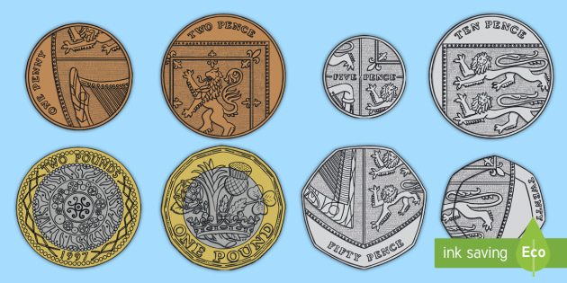

Put them into this table to help you sort them

 | Round | Not round
Bronze
Silver
Gold

Phonics
This week we are learning about homophones.
These are words that sound the the same but they are spelt differently and have different meanings. For example: see / sea hear/here
There are no spelling rules you just have to remember them.
YOUR CHALLENGE
- How many homophones can you think of? I found 20. Can you beat that score? Write all the homophone pairs or more you can think of !
Here are some homophones: see/sea hear/here flower/flour piece/peace
Bear/bare pair/pear break/brake our/hour new/knew to/too/two there/their/they’re would/wood poor/pour weather/whether hare/hair night/knight meet/meat mist/missed tale/tail wait/weight blew/blue
pour/poor/paw mail/male right/write plain/plane one/won sun/son be/bee
- What does each word mean? Make picture cards for homophones. Write homophone and picture,
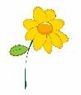
For example flower flour

- Read your reading book. Ask the questions in the front or the back of the book. Ask simple questions – Who are the characters in the book? How would you describe the characters? What happened first? Next? At the end? Were there any parts that made you feel a certain way? Why? Does this book remind you of any other stories you know? How would you change the ending?
Mr Thorne and Geraldine the Giraffe do Phonics. Lots of fun to help with phonics

Mr T's Phonics - YouTube
www.youtube.com › channel
www.phonicsplay.co.uk

Topic
What: Can I explain how to be hygiene (clean)?
Why: So that I stay clean and help prevent the spread of harmful germs?
Remember: The things you do to stay clean.

Watch this video to learn more about hygiene and germs
https://www.bing.com/videos/search?q=germs+for+children&view=detail&mid=38560F33FAC7B9EED1A538560F33FAC7B9EED1A5&FORM=VIRE
Thinking time:
Think about the things you do to stay clean.
How to keep clean
Complete the worksheet below
- Draw pictures to show the ways you keep clean.
- Label your picture

Experiment
The power of soap
- Fill a plate or bowl with water
- Add powder to the top of the water.
- Dip your finger into the water

What do you notice? Write down your thoughts
- Dip your finger into some soap
- Dip your finger back into the powder with your soapy finger

What do you notice?

Hands
Shower or a bath
Teeth
Food
Can you think of one more things?
Draw and label your pictures to show how you keep clean.
How do I keep clean?

