We hope you are enjoying completing the home learning tasks that we are setting for you. It has been lovely to see some of you tweeting your work on Twitter. Don’t forget to tag us, so we see your tweet!
https://twitter.com/DevonshireInf
@Devonshireinf @MrFlemingDevInf @devOrangeClass
@devcreamclass @MsSandhuDevInf

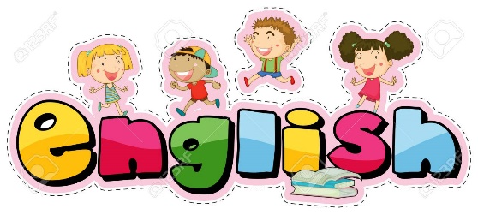

ENGLISH

The week of lessons will continue with the story called ‘The Firemaker’s Daughter’
Please follow this link:
https://classroom.thenational.academy/lessons/the-firework-makers-daughter-to-retrieve-information-e0af6c/activities/1

Work through the video. The first part is spellings. You can practise the spellings like we do normally.

Then continue. Pause the video when answering questions or reading the text.

Remember the CC button on the video gives you subtitles!

Work through the questions slowly, pausing when you need to read or write your answer.

 | 1 | 2 |  | 3 |  | 4 |  | 5
 | look, say and cover | write and check  |  | write and check  |  | write and check  |  | write and check 
look and  say | Improve
 | Sure
 | Sugar
cover | Eye
 | Could
 | Should
write | Again
 | Who
 | Whole
check | Any

Maths –

Choosing an efficient strategy for a problem

Type of problem | Concrete pictorial to support  Does your child understand why their strategy works? | Efficient strategy
2 digit + or - one digit | Number line | Put the number in your head and count forwards or backwards
2 digit + or – ten | 100 sq | Count in 10s from any number forwards or backwards
2 digit + or – two digit | Tens and ones equipment or jottings.  Exchange how to with jottings.  Video? | Add/subtract the tens  add/subtract the ones  Combine the tens and ones.  Exchange when necessary
3 one digits + or – | Regrouping ones.  Choosing the largest number. | Continuing to count on or back

Each day cover a strategy and include a plenary style task about when to use it.
Column method preparation
Exchanging for regrouping.
Create a word problem for each method as extension challenge.
It was 29degrees outside on weds but it got 4 degrees warmer on Friday. What was the temperature?

Maths – choosing an efficient strategy for addition and subtraction.
This week we’ll be covering the strategies taught this year for + and -, and x and ÷. The focus is to be able to solve them in a way that doesn’t use up lots of time.
Today we’ll be thinking about all of the words for addition and subtraction so we’ll need to remember important vocab like
Addition | Subtraction
Total  Sum  Add  increase  Altogether  Together  … and some more. | Minus  Subtract  take away  Less  reduced  the difference between  how many more than…/less than

How to play | example
Count on AND back from any number.  Choose a number to start from.  Roll a die or generate a random number between 1 and 10.  Player 1 counts on from the start number  Player 2 counts back from the start number.  Players then record their number sentences.  Then swap over who is counting on or back. | 25  6  25 26 27 28 29 30 31  so 25 + 6 = 31  25 24 23 22 21 20 19  so 25 – 6 = 19

This will help you with your counting on and back strategies.

Record your calculations from the game below.
Player 1 | Player 2

This strategy isn’t the only way to solve + or – but it is great for when there isn’t much to add or subtract.
Remember that you can swap around the parts that you are adding to make counting on easier.
Can you circle and solve the calculations that would suit using the count on or back in your head?
26 – 7 =
21 + 43 =
52 – 6 =
32 + 30 =
58 – 40 =
6 + 52 =
45 – 3 =
26 + 7 =
3 + 45 =

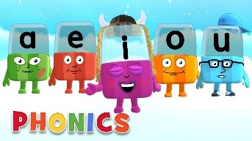
Phonics

Day 1 – This week we will be practising spelling our Common Exception Words. There will be a different set each day.

Please watch the following video to help you:
https://www.youtube.com/watch?v=kfNzqZ6b-2E

Complete the activity below.

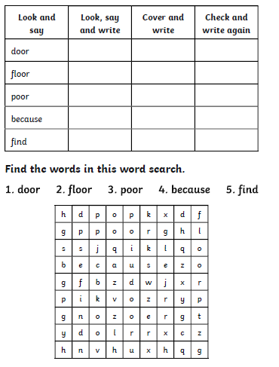
Practise spelling these words.

What does each word mean? Can you spot the vowels? Which letters are consonants?
Read your reading book. Ask the questions in the front or the back of the book.
Ask simple questions – Who are the characters in the book? How would you describe the characters? What happened first? Next? At the end? Were there any parts that made you feel a certain way? Why? Does this book remind you of any other stories you know? How would you change the ending?

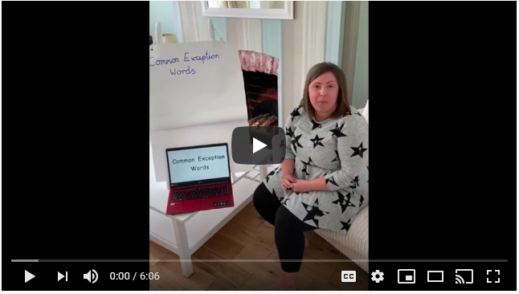

Alphablocks is a great website to support with phonics and with how to pronounce the sounds
https://www.bbc.co.uk/cbeebies/shows/alphablocks
Phonics Play has a range of phonics resources and games
www.phonicsplay.co.uk
Spelling frame has lots of games to practice Year 1 and 2 sounds and common exception words.
https://spellingframe.co.uk/
Education City has games and activities for phonics, some may be set or you can choose your own. After an activity you can print your own certificate too.
www.educationcity.com

Topic – Day 1

End of Year 2 QUIZ
Day 1 Geography there are 11 questions. The answers follow after plus 2 follow up activities.

1. Use the picture clues to name the 4 capital cities of the United Kingdom
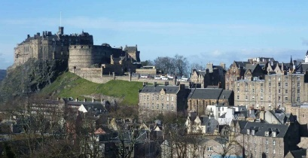
A.
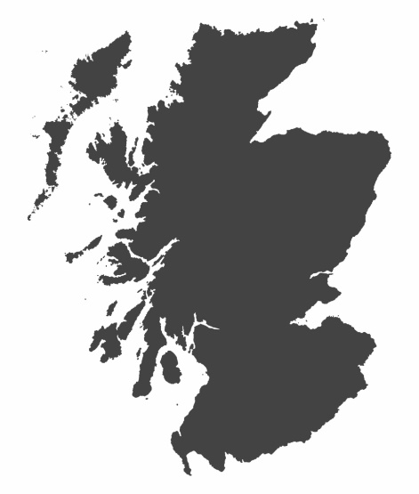

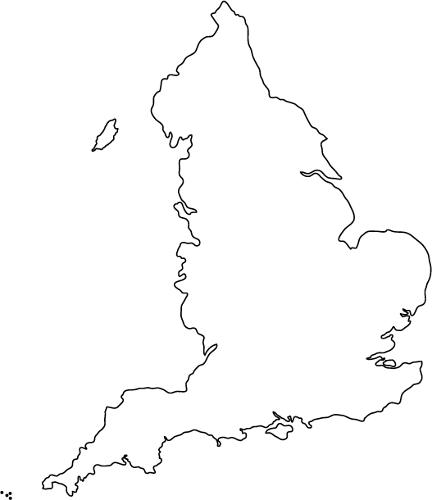
B.

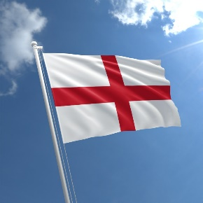

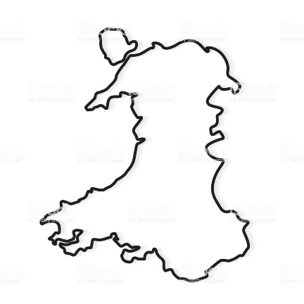
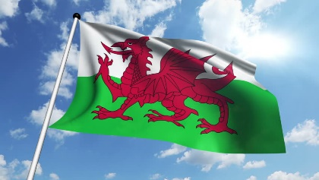
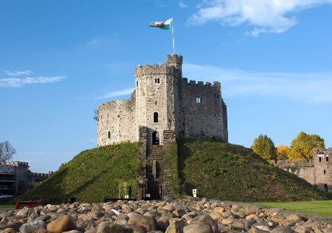
C.

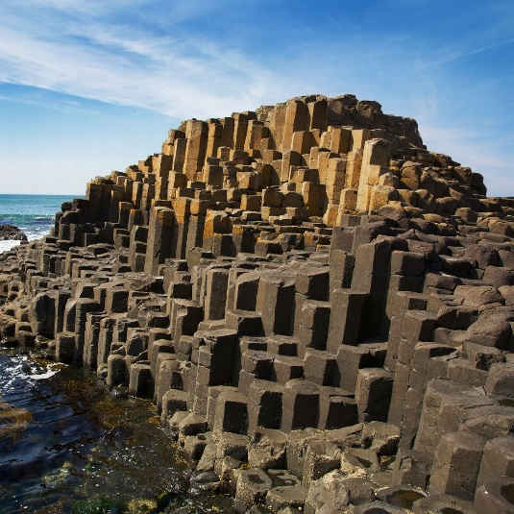
D.
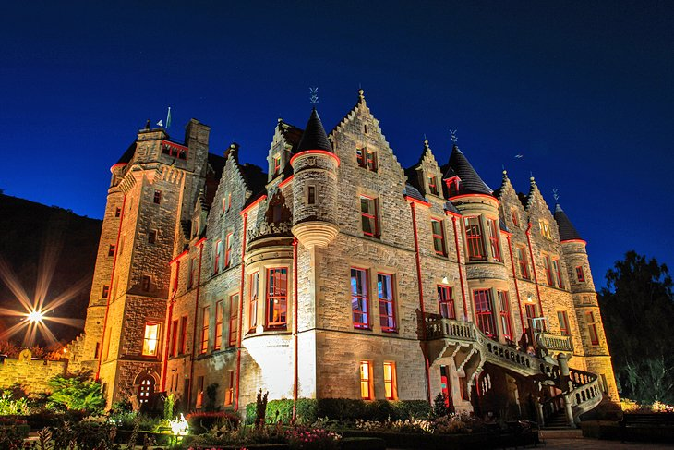
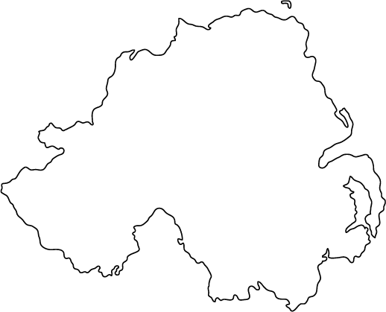

2. Can you name the 5 oceans of the world?
A - - - - -, A - - - - - - -, I - - - - -, P- - - - - - and S - - - - - - - oceans
3. Can you name the 7 continents of the world?
A - - - , A - - - - - , N- - - - A - - - - - -, S - - - - A - - - - - -, A - - - - - - - - -, E - - - - -, and A- - - - - - - -.

4. On which continent do you find these animals? Can you name them?

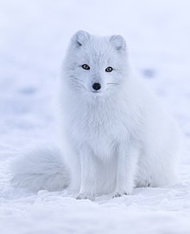

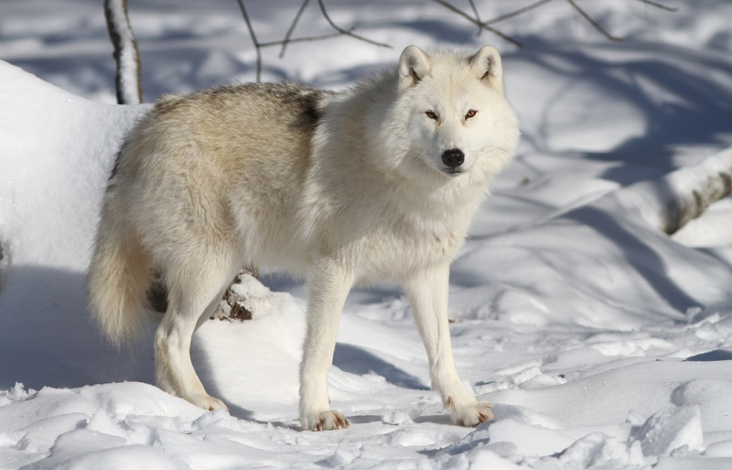

5. On which continent do you find these animals? Can you name them?

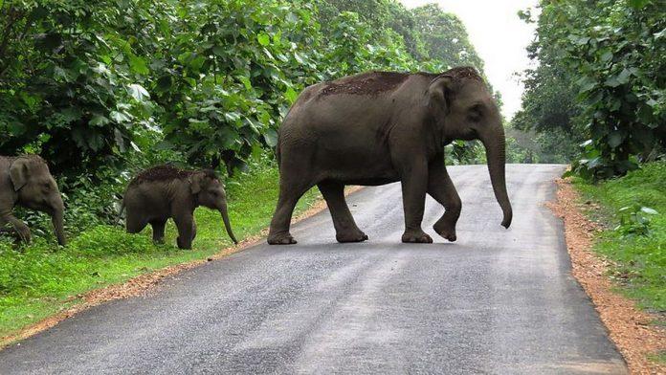

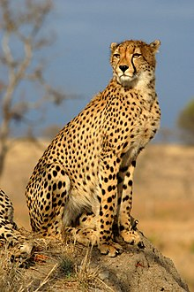
6. On which continent do you find these animals? Can you name them ?
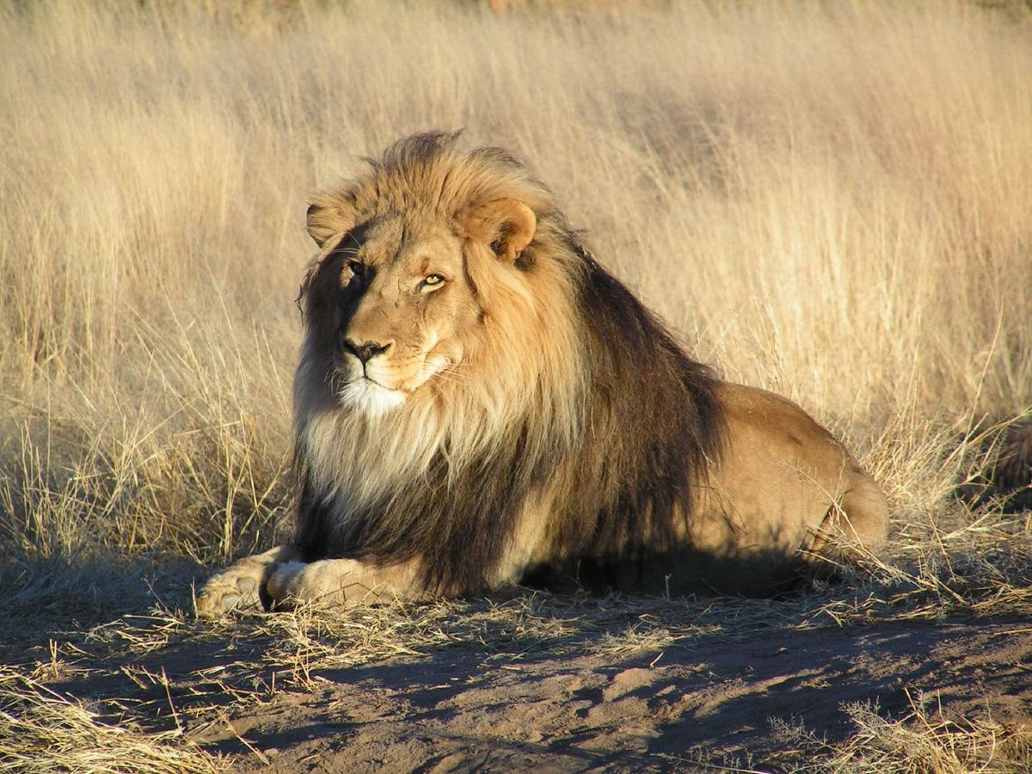

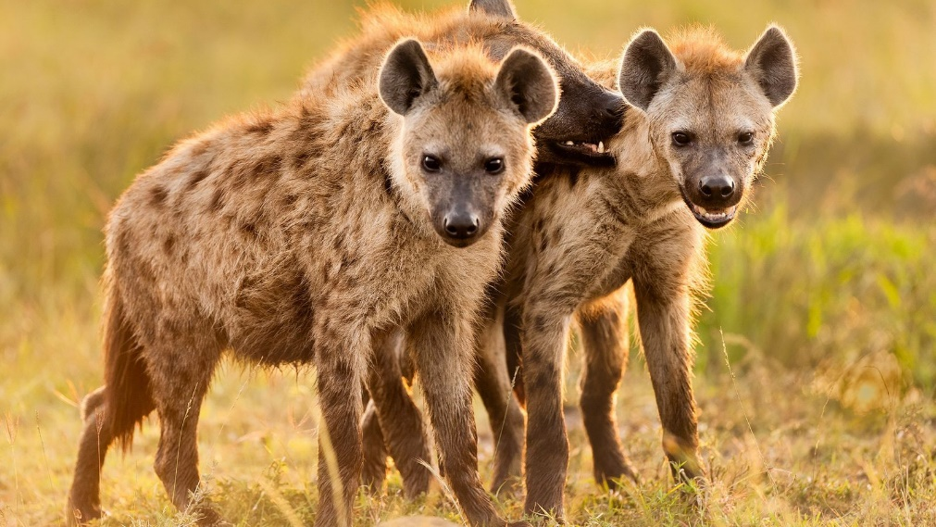

7. Do you recognise this aerial photograph? What special place is it?
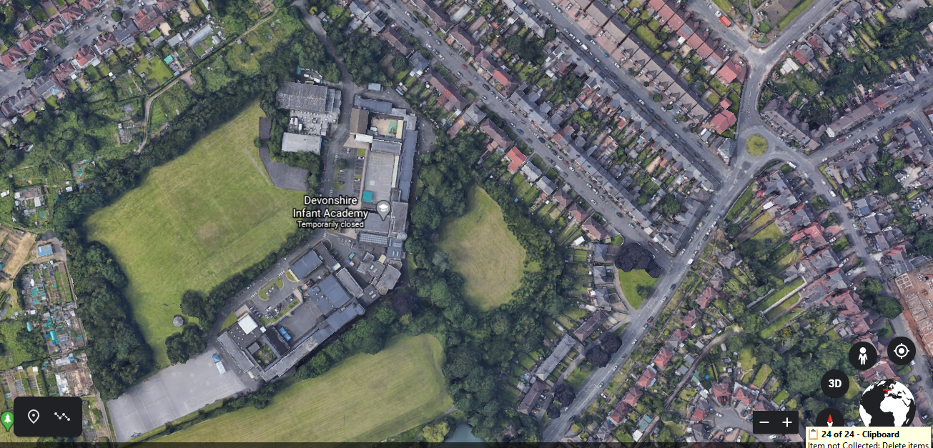

8. Can you name this river from the aerial photograph?
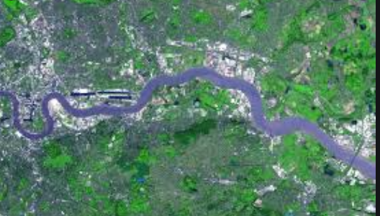

9. Do you know what these OS (Ordinance Survey) map symbols represent?

10. Do you know your compass directions?
You are in the Western Hills in what direction is Gull Rock?

11. Here is a picture of Galton Bridge Heritage centre next to the canal. Are canals a physical or human feature?
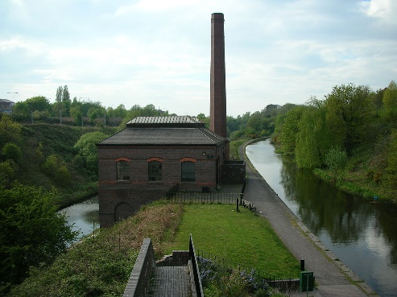

ANSWERS
1A Edinburgh capital city of Scotland
Pictures: Edinburgh castle, Scottish flag and map outline of Scotland
1B London capital city of England
Pictures: Big Ben and Houses of Parliament, English flag and map outline of England
1C Cardiff capital city of Wales
Pictures : Cardiff Castle, welsh flag, map outline of Wales
1D Belfast capital city of Northern Ireland
Pictures: Belfast Castle. Giant’s Causeway Northern Ireland, map online of Northern Ireland
2. Arctic, Atlantic, Indian, Pacific and Southern oceans
3. Asia, Africa, North America, South America, Antarctica, Europe, and Australia.
4.Artic – walrus, Artic fox, Artic wolf
5. Asia- Asian elephant, panda, Indian tiger, snow leopard
6.Africa – lion, cheetah, hyena
7. Devonshire Infant School
8. River Thames London England
9. Car park, cycle trail, museum
10. North
11 Human - canals were built in the 19th century. Why were canals built? Canals were built as a way of transporting goods around the country. Before canals were built, moving goods around was difficult as there were no engines. Items such as coal and food had to be moved by horse and cart.

Follow up activities
- Explore the world with Google Earth
- Follow link to find out more about maps:
- Ordinance Survey Map sills
https://www.ordnancesurvey.co.uk/mapzone/map-skills/map-symbols

