13.7.20 Work to support your child at home
This week is the last week of term before the Summer holidays. Please check out the website to watch videos of the teachers and information about transition for September.
Maths
This week in maths we are going to recap some of the different maths topics and think about fun maths activities that you can do in the holidays.
We have added lots of different maths games for different maths activities. Look at your child’s school reports and encourage them to play the games from the areas that they have found most difficult.

Today we are going to recap 2D and 3D shapes.

Fun shape videos to watch in the holidays!
https://www.youtube.com/watch?v=guNdJ5MtX1A
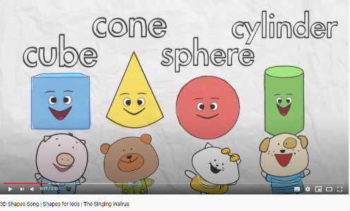
https://www.youtube.com/watch?v=hVl-DfneNBY
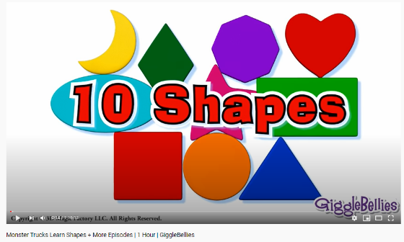
https://www.youtube.com/watch?v=awdthrGmZ4U
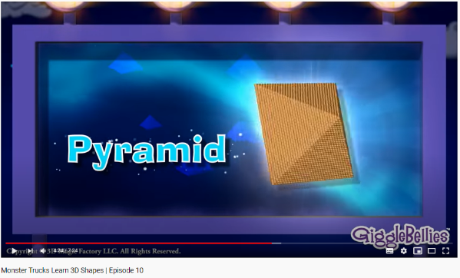

Can you name these shapes and count the number of sides?
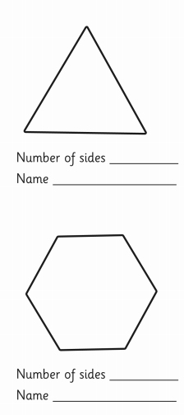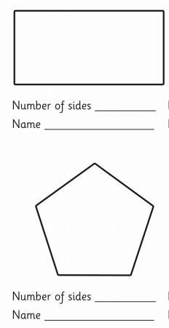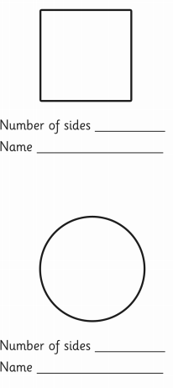
Can you finish these repeating shape patterns?
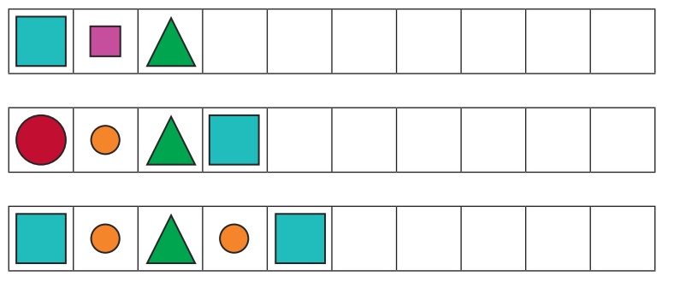
Can you make up your own repeated patterns? You could use paint, chalk or use objects?
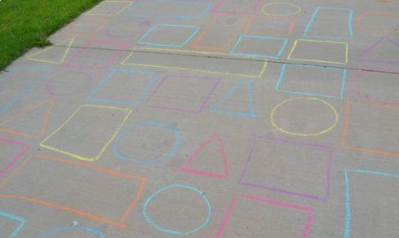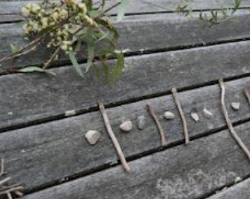

Keep practising the names of these 3D shapes. Talk about things in your home or outside that are different shapes. Describe the shapes talking about curved or flat faces and how many vertices the shape has.

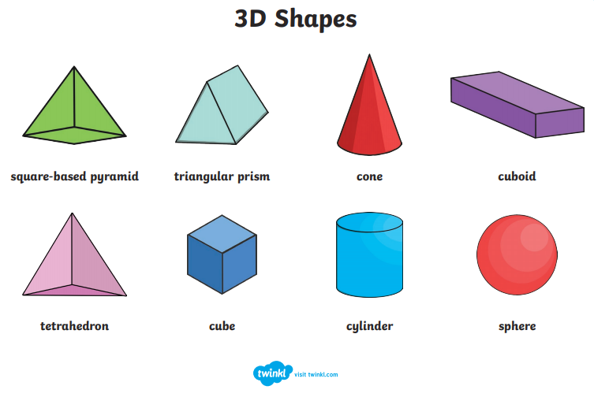
Here are some fun shape riddles from the Twinkl website. Can you make up your own riddle cards?
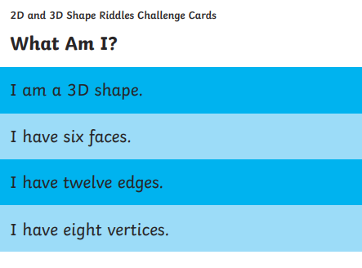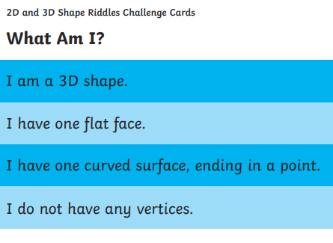
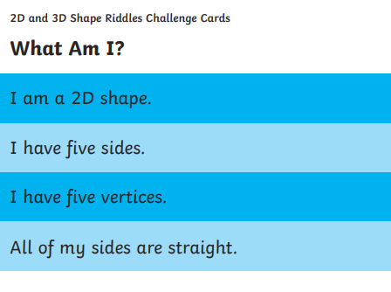

Fun shape games to play online

https://www.topmarks.co.uk/carroll-diagrams/2d-shapes
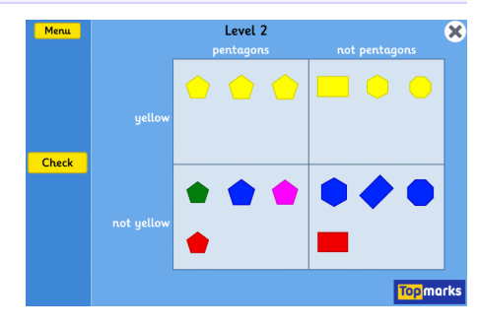

https://www.topmarks.co.uk/ordering-and-sequencing/shape-patterns
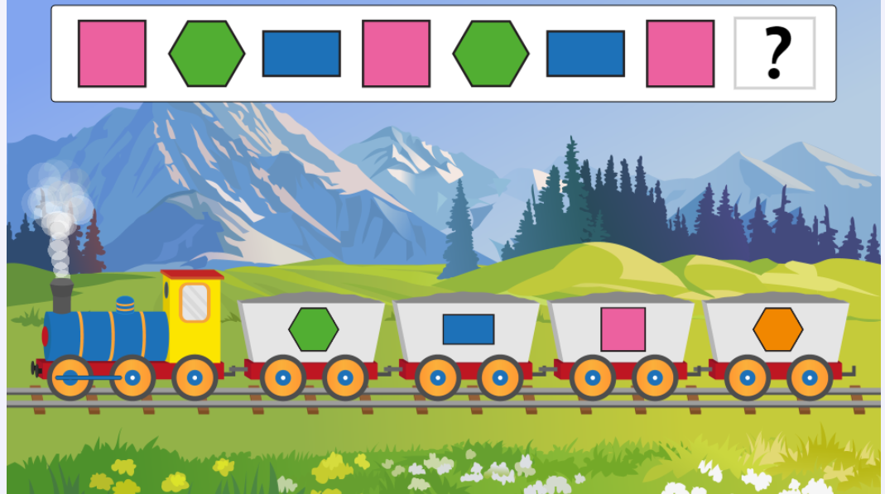

https://www.ictgames.com/mobilePage/shiftingShapes/index.html
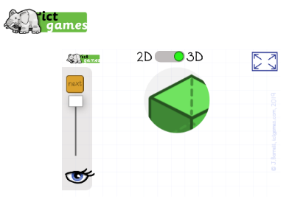
https://www.bbc.co.uk/bitesize/topics/zjkphbk/articles/zf4sscw
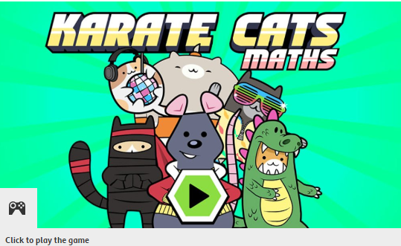

ENGLISH - Monday 13.7.2020
This week is our last week of English work in Year 1. We are all so proud of how hard you have worked this year, both in school and at home. We cannot wait to see you all back at school in September in your new Year 2 classes.
This week, we wanted to take the opportunity to look back at everything that you have learnt to do whilst in Year 1.
Main task:
We have learnt many different styles of writing over the year. Can you remember each of these?
*Instructions
*Stories
*Recounts
*Letters
*Poems
*Reports
For each style of writing, write down 3 things that you remember about that style.
You could present your work like this:
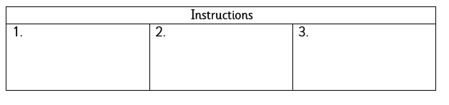
Or like this:
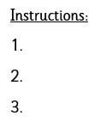
If you are getting stuck, watch these videos to help you….
Instructions: https://www.bbc.co.uk/bitesize/topics/zkgcwmn/articles/zfrcmfr
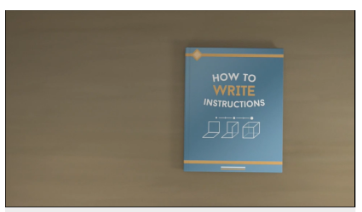
Recount: https://www.bbc.co.uk/teach/class-clips-video/english-ks1-ks2-how-to-write-a-recount/z7dg92p
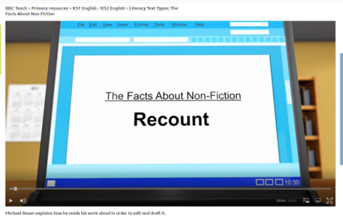
Letters: https://www.youtube.com/watch?v=gpeo_0yoD0k
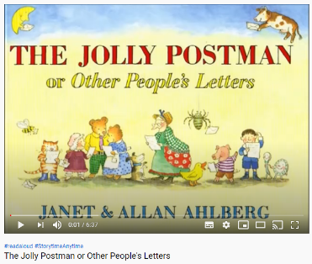
Poems: https://www.bbc.co.uk/bitesize/topics/zjhhvcw/articles/zg6dng8
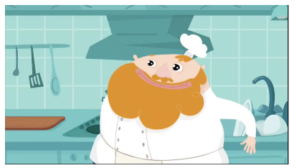
Report: https://www.bbc.co.uk/bitesize/topics/zkgcwmn/articles/zffy92p
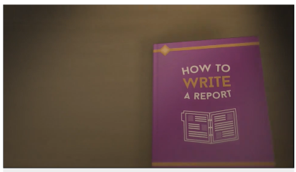

Phonics

Day 1 – Learn the new sounds This week we are learning to add un at the beginning of a word. A prefix is the bit added onto the beginning of a word to make a new word.
For example, undo.

Watch this YouTube video to help. Remember always let a grown up know what you are going to watch.

https://www.youtube.com/watch?v=oL8liysUf6s
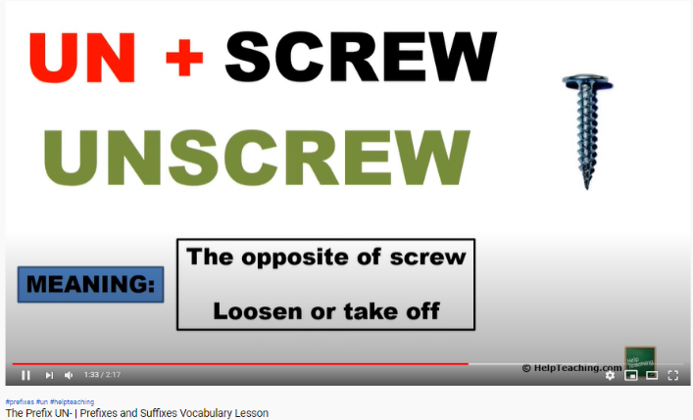
Read your reading book. Ask the questions in the front or the back of the book. Can you spot words with any of the sticky sounds from this week in your book? Write them down and show your grown up.

Have a competition with someone in your house to see who can come up with the most words that have the prefix un

Topic- Art
Later this week you will be organising and taking part in your very own ‘At Home’ Sports Day with your family! Today and tomorrow you will enjoy designing and making some awards to hand out to all the participants (Mum, brother, sister etc.)
There are some ideas you can make below.
Today you will spend time deciding what you will make, what you will need and gathering these resources and thinking about what you will write on the awards (e.g. the speediest……the best effort….for not giving up… etc).
Use things you have in your house. Most of the awards below are either made from paper plates, card/paper, felt tips/paint or ribbon.
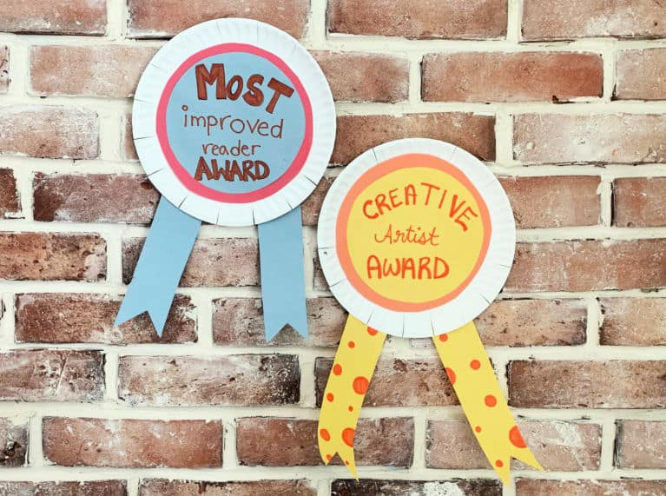 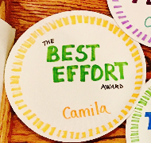 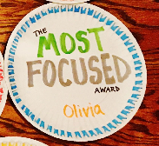Y
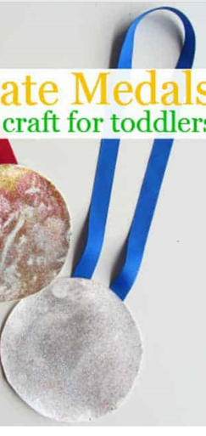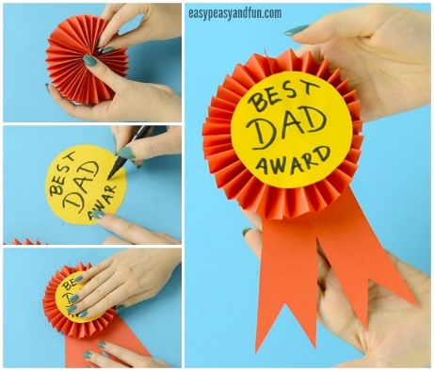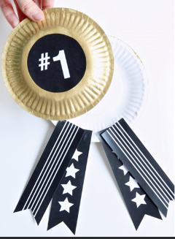
What I will need: What I will write on the awards:
- ___________________________________________
- ___________________________________________
- ___________________________________________
- ___________________________________________
-

