Work to support your child at home
Below are some examples of how you can support your child at home with English, Maths, Phonics and Topic. We have set this out into daily activities. Children learn best with daily practise and by repeating the learning.

Tuesday Tasks
English
Complete your plan and begin to learn the facts. Put actions to your report. Can you learn it off by heart? THINK, is it exciting? Are all of your facts in the right section? Do your facts go in order? E.g. Neil Armstrong died then went to the moon. Can you add any more detail? Does your report make sense?

Phonics
- Practice spellings on:
https://www.youtube.com/watch?v=Jw4IjeGPaz0
- Play games with your homophones cards. For example, snap, matching games, memory matching game: turn cards picture face down turn over 2 at a time and keep pair if match or turn face down again.

- Read your reading book

Maths
Maths warm up - Using your 5X tables cards play a matching memory game. Cut out the cards and turn them upside down on the table. Player one turns one card and tries to match it to its answer. If they find the answer, they keep the pair. Repeat with player 2.
See how fast you can answer all of the X5 cards.

Can you play Money Line up?
With 2 players
Have a mix of silver and bronze coins.
Take turns in placing a coin onto the grid.
Each player is trying to make a total of 50p in a straight line, vertically or horizontally.

Topic

What: Can I identify the symptoms of an illness.
Why: So that I recognise when I’m feeling unwell.
Remembers: There are lots of illness but they are not all the same

Think about a time they were ill. How did you know you were ill? Did you have a temperature, sick, spots?
Things like spots, feeling sick are called symptoms
The diagnosis is where you look at the symptoms and diagnose or decide what the illness or problem might be.
Now we are going to look at the corona virus. Read this article:
https://www.npr.org/sections/goatsandsoda/2020/02/28/809580453/just-for-kids-a-comic-exploring-the-new-coronavirus?t=1584605049132
https://www.bbc.co.uk/newsround/51887051
You should realise that you are very unlikely to get it, but germs can spread very quickly and so we can stop them by doing different things.
Using the information on the website, can you create a poster to show people what to do to stop corona from spreading. Things such as washing hands, stay away from people who might be ill or have the virus.
You can use things such as bubble writing, pictures, print out photos.

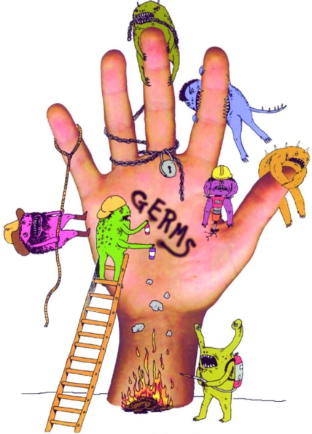
My Poster
- Remember How to stay safe
- Give your poster a title
- Remember your facts
- Draw some pictures

