9.7.20 Work to support your child at home
Maths
Today we are going to think about how to add or subtract 10 to a number.
To start with you might want to use a hundred square or something to use like pasta and raisins as ten sticks and ones cubes.
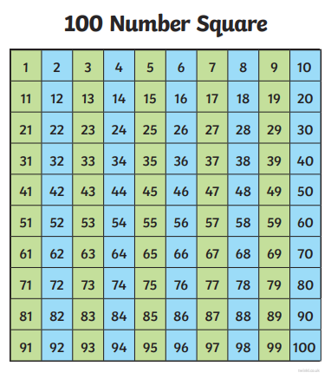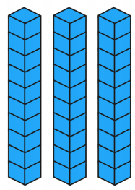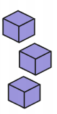
Watch Miss Guest use a hundred square or pasta and raisins to work out ten more and ten less.
https://www.youtube.com/watch?v=yNmrpn0Y5YI
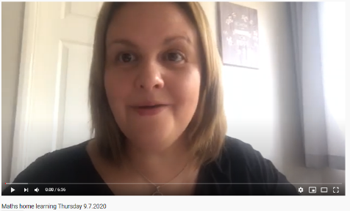

See if you can complete this table.
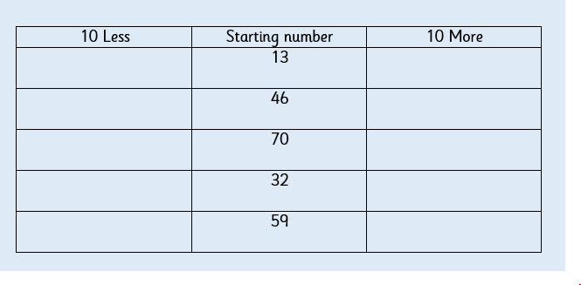

If you are finding this difficult then this video might help.
https://www.youtube.com/watch?v=M2O8uhq5lLg

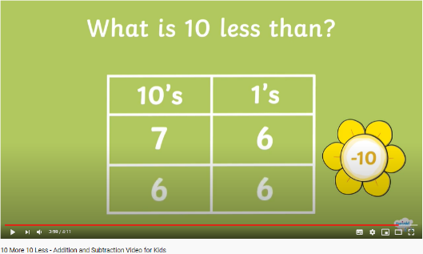
Here is a game where you can practise adding 10 to a number.
https://www.ictgames.com/mobilePage/depthCharger/index.html
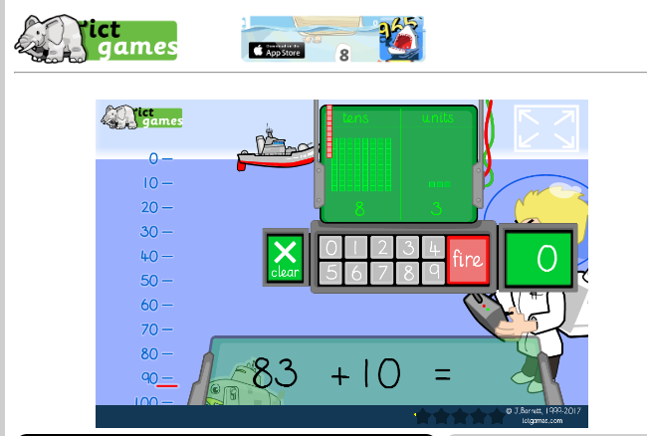

RED HOT CHALLENGE

If you know how to add 10 to a number, then now you can try adding multiples of ten like 20, 30 or 40 to a number. Again the ones digit in these numbers is a 0 so we are not adding on any ones, just lots of ten.
Can you complete these sequences?
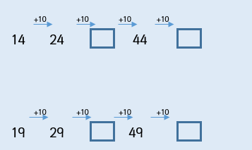
Now try subtracting 10.
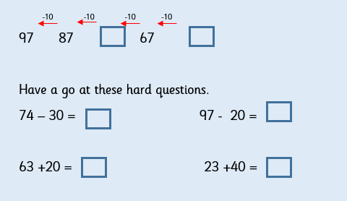

ENGLISH- Thursday 9.7.2020
This week we are looking at the story ‘Where the wild things are’.
Today, you are going to make up and plan out your own adventure for Max and his boat. You have proved that you can write beautiful, imaginative stories which we love reading on Twitter. Don’t worry, we’re here to help you!
First, I want you to sit with a grown up and enjoy reading this story about Max and the Monster, so that you can see an example of what we are looking for this week. Then, I will help you to begin to plan your own story.
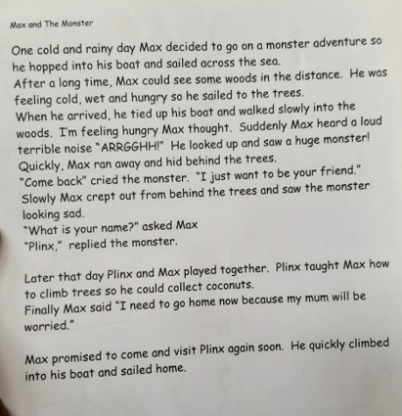

Main task:
Find an empty page in your home learning book and draw some lines so that you can make your plan like you have done for your other stories.
Today, you are going to draw out your story plan. Before we write, we always plan first. You have been really good at this:
CELEBRATE SUCCESS: 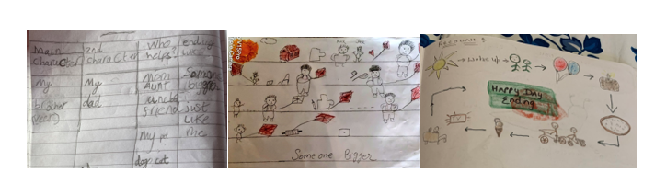
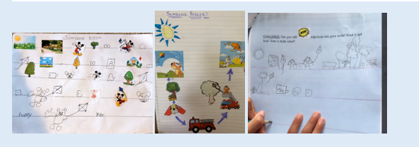

You can box up your ideas first, so that you know what parts you are going to change:
Next, on your plan, can you tell me (IN DRAWINGS ONLY!!):
*What opener will you use to start your story?
*Who is your main character (Max) and what is he travelling in (a boat)?
*Where is he going?
*How does he feel?
*Who does he meet?
*What do they say to each other?
*What does Max learn to do?
*How does your story end?
CHALLENGES: *Can you add adjectives into your work? Read it out loud. Does it make sense?
*Can you add more openers? You’ll see on my plan that I have added Quickly.

This is my plan:
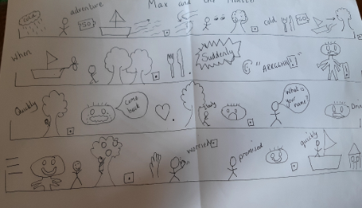

Phonics
Day 4 – Have a spelling competition using the words you have learnt this week. How many words can you think of that have three or more syllables in?
How many words can you spell? Time yourself, how many words can you write in 1minute?
Look at these sentences below and read them. Do most words have one syllable in the sentence? Can you find any words that have 4 syllables?

My mum said I can buy a toy helicopter.

My sister is very scared of crocodiles!

‘Did you know I have a caterpillar as a pet?

I’d love to make some sandwiches to eat.

I think we might have a thunder storm today.

Do you think we can have some watermelon after dinner?

Shall we play a maths game altogether
In the video Mr Thorne practises reading alien/nonsense words that have 2 syllables. Can you read these words before he says them?
https://www.youtube.com/watch?v=PyKPO5RO5YM
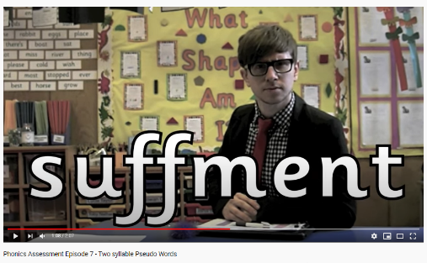

Topic- PHSE
Water Safety

The weather has been lovely and we know that when it is hot we all want to cool ourselves down by enjoying some water play. Some of us even have paddling pools at home that we enjoy using! Although water is really fun to play with and in, it can be very dangerous if you are not careful.

**Although it might be tempting to visit the beach with a grown up, it’s not a good idea to do so at this time because lots of people are doing the same! Earlier in the week we learnt more about how to be safe around the coronavirus. Keeping a safe distance from people not in your household is one way to keep yourself and others safe. At a very busy beach it may not be possible to socially distance from others. So as well as considering how to stay safe around water, you must also think about staying safe around COVID 19.

Look at the photos below. Discuss whether or not the following places are safe for water play.
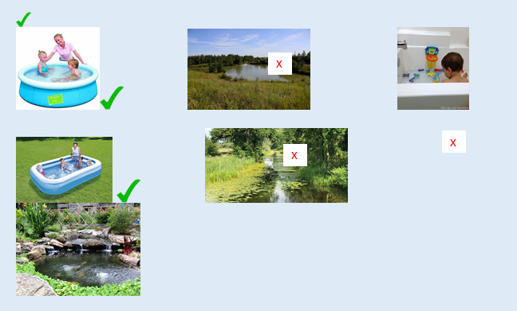

Paddling pools and the bath are fun to play in but remember to only use these when there is an adult supervising you. Also, you must make sure that you follow the sun safety rules we looked at earlier in the week when using the paddling pool. Are there any other things that you must do to stay safe when using a paddling pool or bath? (E.g. no running, no diving, no jumping in etc).

