Work to support your child at home
Below are some examples of how you can support your child at home with English, Maths, Phonics and Topic. We have set this out into daily activities. Children learn best with daily practise and by repeating the learning.

Wednesday Tasks
English
Begin to write your report into your home learning book. Remember to try and use the handwriting joins you have learnt at school. Don’t forget to use: interesting sentence starters (Did you know…. Way back in …… Interestingly), capital letters for the beginning of a sentence and for the names of people and places, use a range of sentence types (question, exclamation, statement, command), conjunctions (because, but, so, if, when, and), exciting adjectives (describing words), adverbs (describing the verb, quickly, slowly, loudly), and check it makes sense.

Phonics
Homophones : see/sea hear/here flower/flour piece/peace bear/bare pair/pear break/brake our/hour new/knew to/too/two there/their/they’re would/wood poor/pour weather/whether hare/hair night/knight meet/meat mist/missed tale/tail wait/weight blew/blue pour/poor/paw mail/male right/write plain/plane one/won sun/son be/bee

- Write sentences using the homophones above. Remember good handwriting, and punctuation. So start sentences with capital letters and end full stop . ? or !
For example, I ate a pear at fruit time. My socks are tidy and all in pairs.
- Share a book together.

Maths
Maths warm up - Using your 3X tables cards play a matching memory game. Cut out the cards and turn them upside down on the table. Player one turns one card and tries to match it to its answer. If they find the answer, they keep the pair. Repeat with player 2.
See how fast you can answer all of the X3 cards.

Money

Can you solve these money problems?
Count on in 10s and 1s to find how much more is needed.
Keep track by jotting a | to mean 10, and . to mean 1.

Dan goes to the shop and wants to buy a treat.
Here’s his money.
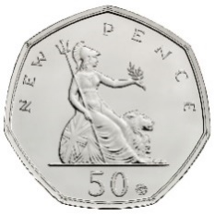
How much more does he need to buy a doll? __________
A doll costs 60p but he only has 50p. I’ll count on to see how much more he needs.
Count in 10s and keep track of how many I counted.

50 +10 is 60. It took one 10 to get there. Dan needs 10 more p.
||||| | makes 60 so I only needed one | more.
| meant 10 so he needs 10p more.

How much more does he need to buy a teddy? __________ 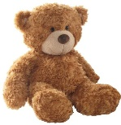 63p

How much more does he need to buy a skipping rope? __________ 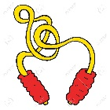 72p

How much more does he need to buy a jack in the box? __________ 85p

How much more does he need to buy a ball? __________ 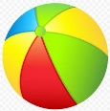 78p

How much more does he need to buy a yo-yo? __________ 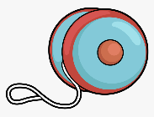 86p

How much more does he need to buy a puzzle? __________ 97p

How much more does he need to buy a car? __________ 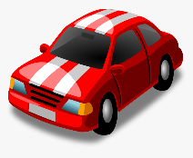 £1.20

How much more does he need to buy a fire engine? __________ 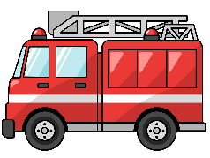 86p

How much more does he need to buy a crayons? __________ £1.10

Topic
What: Can I understand what effect exercise has on our body?
Why: So that I can understand why it is important to do exercise.
Ask your child: What does your heart do? It pumps blood around the body. Why?

https://www.bbc.co.uk/bitesize/topics/zwdr6yc/articles/zs8f8mn - this explains what the heart and blood is used for.

We need the blood to deliver energy and oxygen to everywhere in our body. When we exercise, our body needs more energy so we can keep going. So how do you think our body gets more energy around it? Our heart might beat harder or faster.
Let your child have the worksheet below. Now, we are going to check to check our heart rates. Show children how to do it, they are going to do it for 30 seconds then double it, or just get them to count for a full minute.
They are then going to do ‘Jump start Jonny’ after that they are going to check their heart rate. Can the children tell you how much more it has increased to?
https://www.youtube.com/results?search_query=jump+start+jonny
Ask your child what else has changed about their bodies as well as their heart beating faster?

WEDNESDAY Can I understand what effect exercise has on our body?
So that I can understand why it is important to do exercise.

Resting heart rate: bpm (beats per minute)
Heart rate after exercise: bpm
What has changed about your body? Can you label them on the body?

Sweaty
Warm
Red
Tired
Achy
Sore
Stitch

