7.7.2020 Work to support your child at home
Maths
Today we are going to think about spotting addtion questions that are easy to answer. We have already learnt that if we add 0 to a number then the answer doesn’t get bigger or smaller it stays the same. So if you see questions like these below then they are really easy to answer.
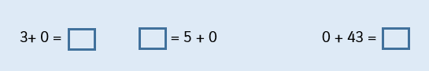

We have also practised learning our doubles to 10 in school. Watch this video to learn more about doublling numbers.
https://www.youtube.com/watch?v=4U2QLjqripY
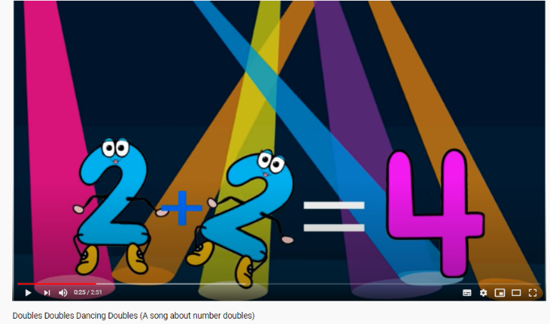
So if you spot an addition number sentence where both numbers are the same then you know it is a double. You probablly then know the answer in your head.
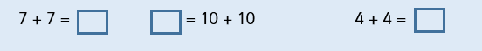
We have also practised number bonds to 10, in school. If we know quickly which two numbers add up to 10, then this can help us to add larger numbers in the future.
Can you remember the Farmer Pete song that helps us to learn number bonds to 10?
https://www.youtube.com/watch?v=poJmS5iWfEs
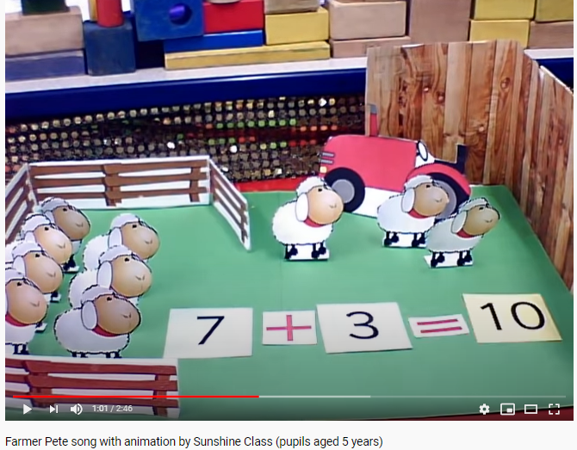
If you see questions like these then your brain will know the answers quickly.

Now we are going to train your brain to spot these types of questions. Look at the 20 addition number sentences below. You can do any of the three ways to spot and sort the different types of questions. Watch Miss Guest show you the different ways on YouTube. https://www.youtube.com/watch?v=7cheeTRsyA0
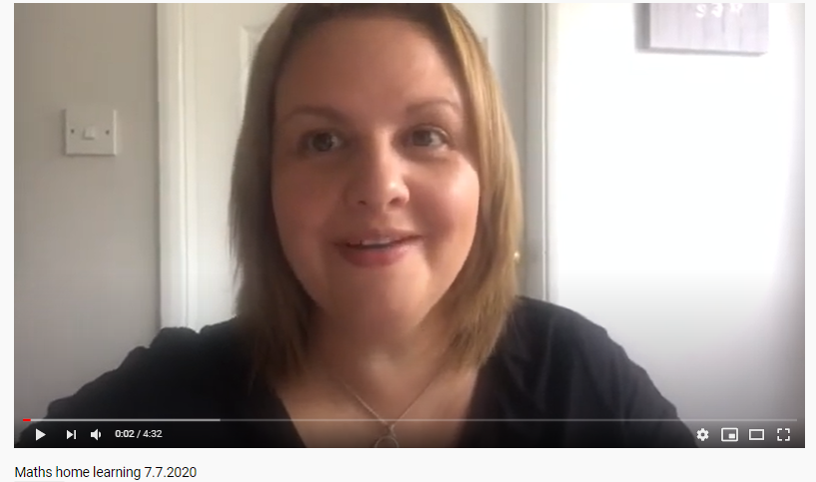

- Use 3 different coloured pencil crayons and colour over the different types of questions. Are there any questions that need 2 colours?
E.g. Blue = doubles Yellow = number bonds to 10 Pink = add 0

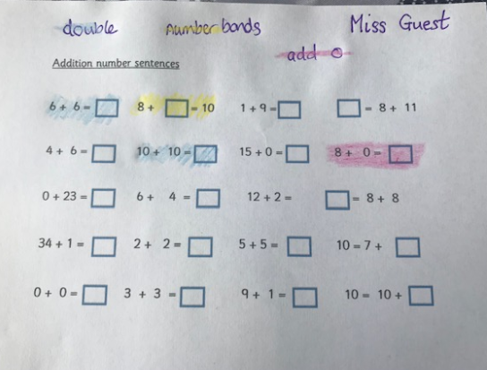

- Make 4 columns in a table in your home learning books and write the types of questions in the correct column.
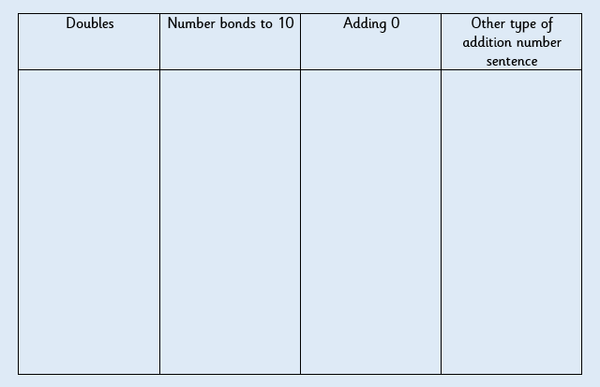
- Again using different coloured pencils, you can track and loop across each line. You can time yourself and see if you can do this faster than your brother, sister or parents.

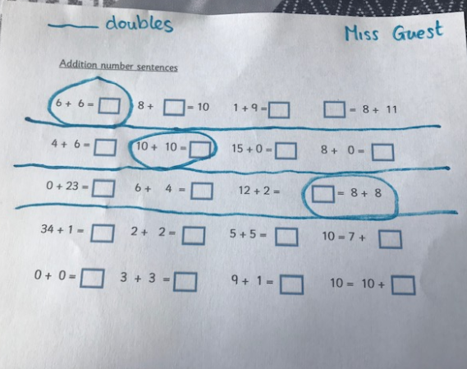
Addition number sentences
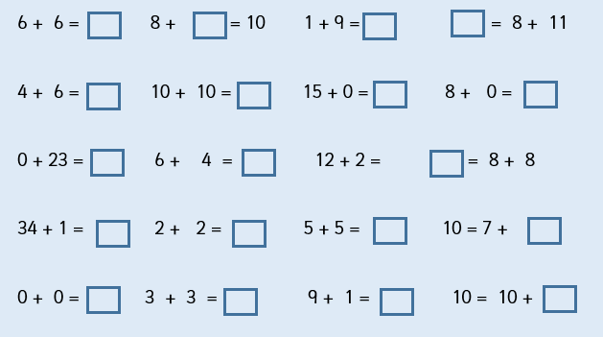

If you need more practise learning your number bonds to 10, then this is a good game to play.
http://www.ictgames.com/saveTheWhale/index.html
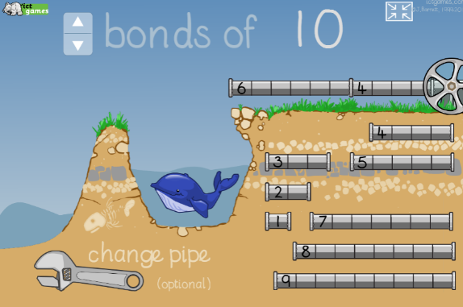

RED HOT CHALLENGE
If you know your number bonds to 10 then this will help to learn number bonds to 20.

https://www.youtube.com/watch?v=hTboVxIbXns
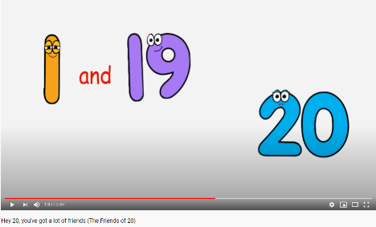
You can look at the ones digit then you can find the pairs that make ten. Then when you have two sets of ten it will make 20.
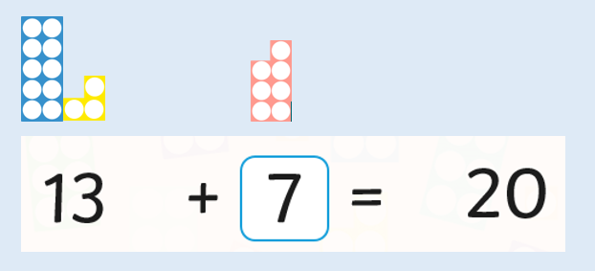
You can see that the 3 and the 7 are number bonds that add up to 10.
We then have two sets of 10 which make 20 altogether.

See if you can spot the number bonds to 20 in the addition number sentences below.

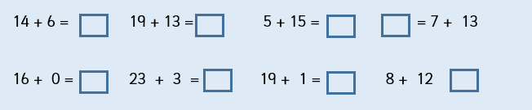
This is a good game to play to practise number bonds to 20.
https://www.ictgames.com/mobilePage/smoothie/index.html
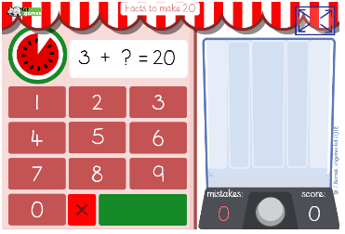

ENGLISH- Tuesday 7.7.2020
This week we are looking at the story ‘Where the wild things are’.
When we read a story, it is really important to remember it well enough to be able to re-tell it.
Main task:
*Using these pictures, can you tell your adult what is happening in the story?
If you get stuck, let Mrs Patton read the story to you again to help you:
https://twitter.com/devnursery/status/1260145126686556163?s=19

https://twitter.com/devnursery/status/1260145449291386881?s=19

*Once you have remembered what is happening in each picture, can you put them into the right order?
You can print them out and cut around them.
Or, I have added numbers to each picture, so that if you cannot print them out, you can just write the numbers down into your home learning book to tell us which order they should be in (Eg picture 3 may come first).
CHALLENGE: Can you write a short sentence to describe what is happening in each picture?

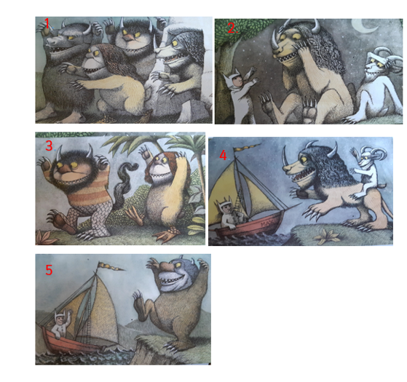

PHONICS
Watch this YouTube video. Always check with a grown up first.
https://www.youtube.com/watch?v=cGEIZoBlkYE
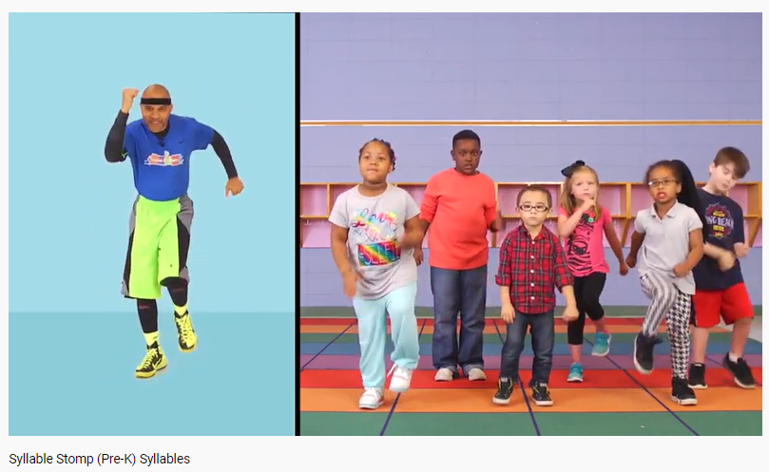

Sort these words into 1,2,3 or 4 syllables.

boy pen cat hop whistle
tissue spikey alphabet dinosaur

jump run jump Tuesday

macaroni rhinoceros

Draw a table like the one below into you Home Learning book and sort the words. Some have been done for you.
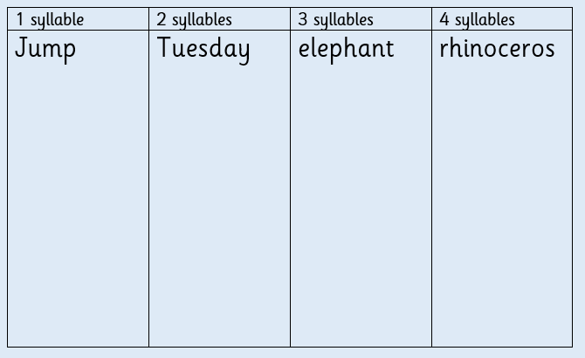
New phonics games on Education City this week.
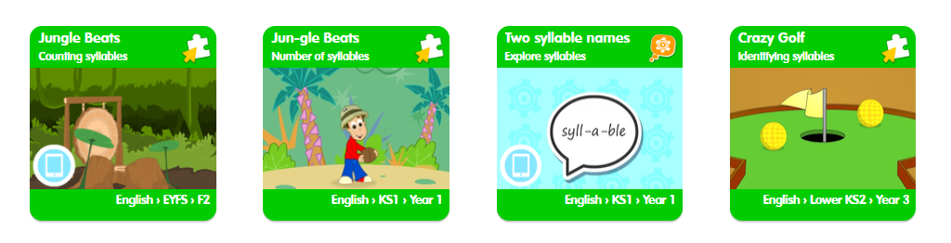

Topic – PHSE
Staying safe from COVID-19

Today we will be finding out some facts about the Coronavirus so that we know how to safe around it. Enjoy watching the following video or having a read of the screenshots below. After this you will do a really fun experiment which will show you why it is so important to wash your hands with soap regularly!

https://www.youtube.com/watch?v=fCjDo9SskQU

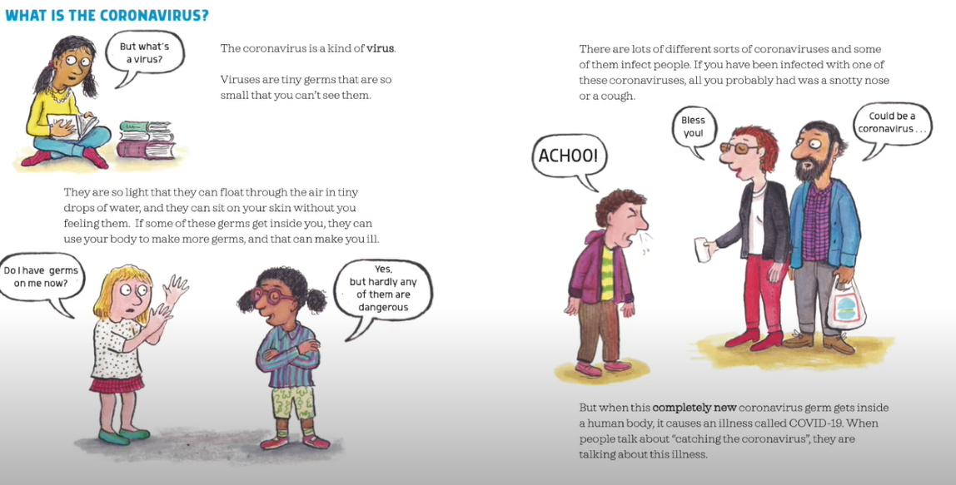

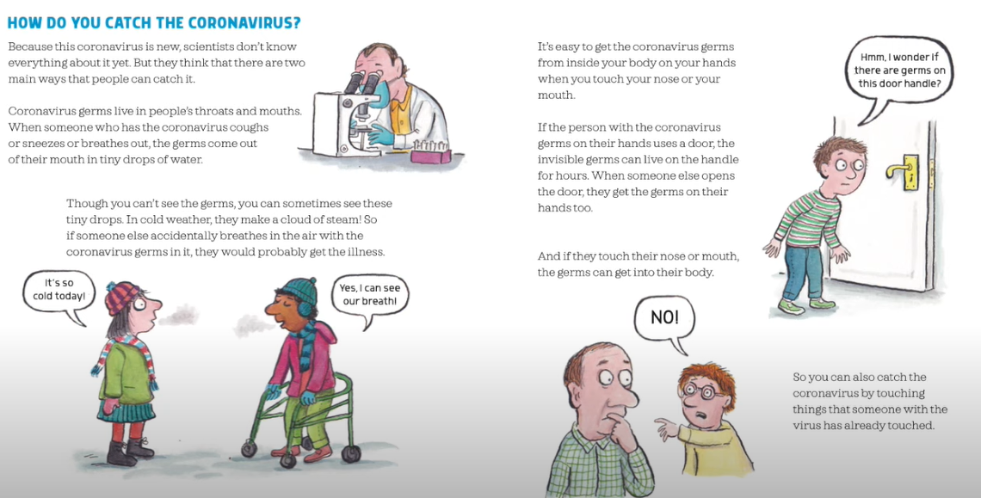

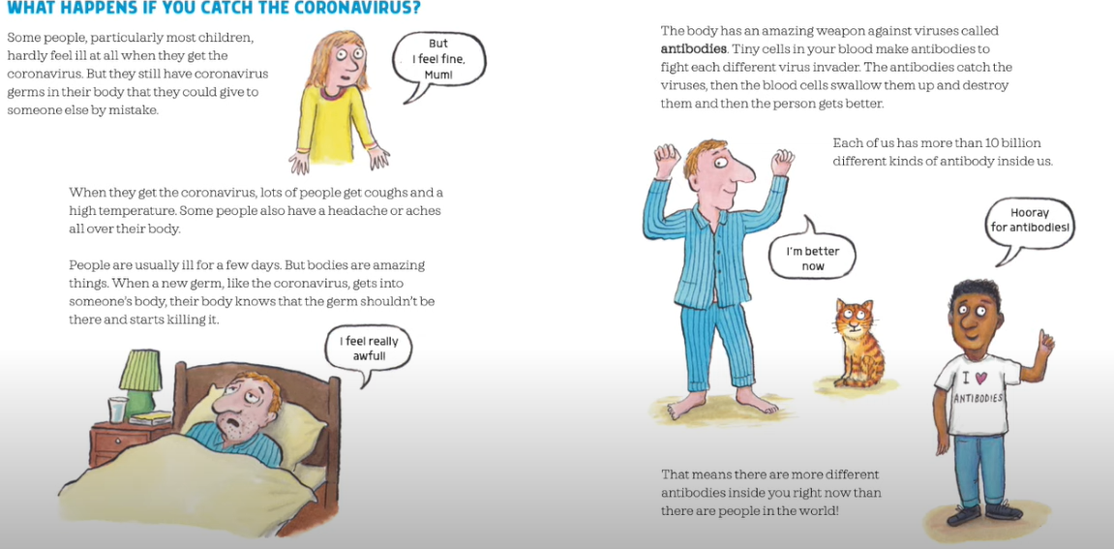

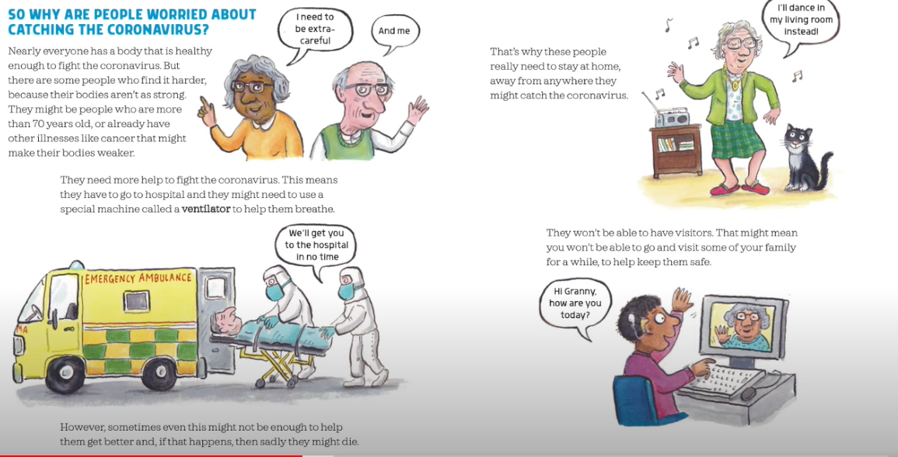
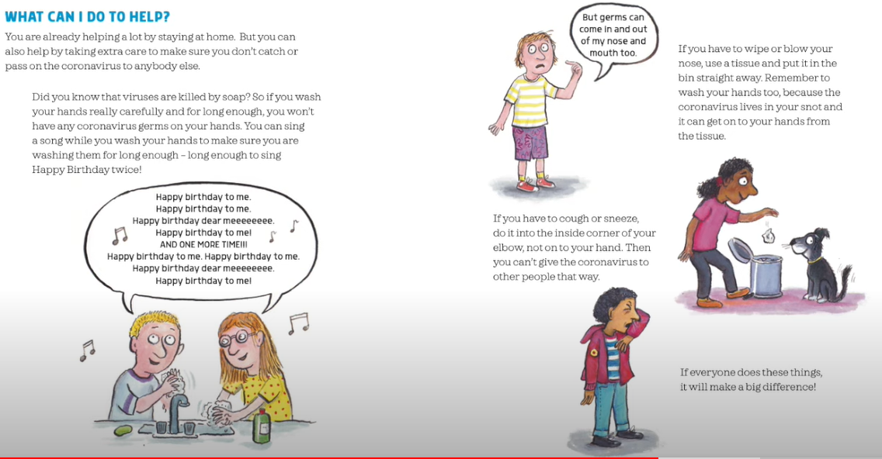
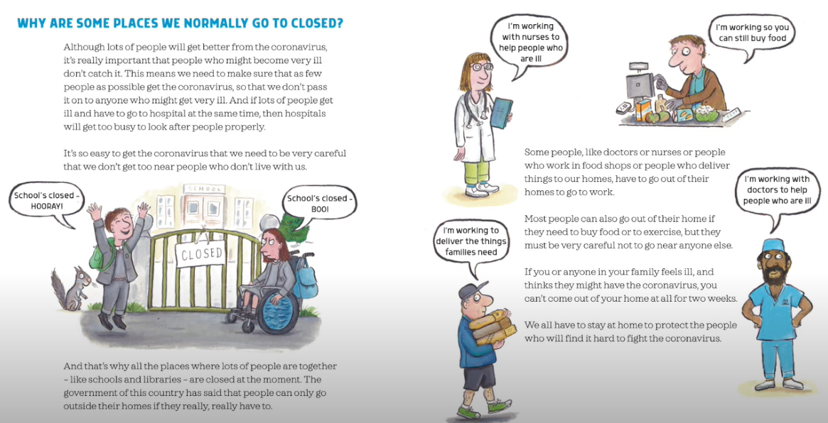
It is really important that we keep our distance from people who do not live in the same house as us. This will protect us all from passing the virus on. We must also remember to wash our hands with soap regularly as the coronavirus germs (and other viruses) are killed by soap. Have a go at the following:

Let’s do a fun experiment!
We are going to pretend that the pepper is germs! Watch this short video to find out how to do the experiment: https://www.youtube.com/watch?v=djxmuDz8c3s

If you don’t have a computer, don’t worry.

You will need:
- Plate of water
- Black pepper
- Soap

- Sprinkle some pepper onto the water in the plate.
- Pop your finger into the water. Notice what happens.
- Cover a different finger with soap and pop this finger into the water. Notice what happens to the pepper!

