It has been lovely to see some of you tweeting your work on Twitter. Don’t forget to tag us, so we see your tweet!
https://twitter.com/DevonshireInf
@Devonshireinf @MrFlemingDevInf @devOrangeClass
@devcreamclass @MsSandhuDevInf
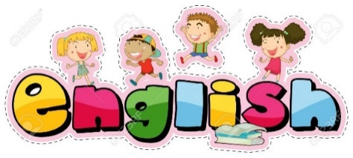

ENGLISH

Today’s link is here:
https://classroom.thenational.academy/lessons/to-identify-syllables/activities/1
This lesson is about syllabales:

The teacher discusses this and shows syllables in both words and sentences.

This is important because in the next lesson you are going to be looking at syllables in a special poem called a HAIKU.
Maths –

Fractions - Warm up
Practise half 12, 14, 16, 18 a lot and double 6, 7, 8, 9.
Colour each pair of number facts in a different colour to help you remember.

Half of 10 is…5
Half of 12 is…6
Half of 14 is…7
Half of 16 is…8
Half of 18 is…9

Double 5 is…10
Double 6 is…12
Double 7 is…14
Double 8 is…16
Double 9 is…18

Main
Can I find fractions of amounts when the numerator has more than one?
Look at the fraction guide
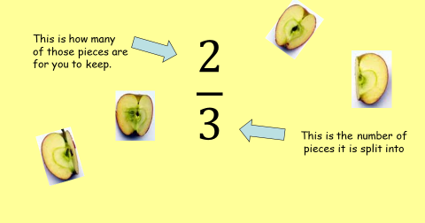

Shade or colour $\frac{2}{3}$ (two thirds) of these shapes.
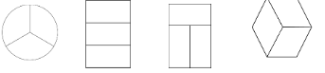

Shade or colour $\frac{3}{4}$ (three quarters) of these shapes.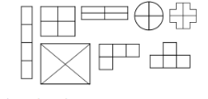
To find two thirds and three quarters of an amount we need to use our strategy from this week AND one more step.
Example.
Read the problem | Step 1  Share the total equally between the denominator (the bottom number). | Step 2  Check how many parts to give to yourself (the numerator at the top of the fraction). | Solution  Count up how much is in these amounts.
$$\frac{2}{3} of 9=$$ | 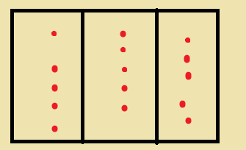 | 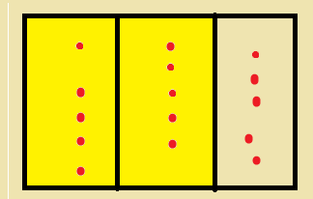 | 5 + 5 = 10
$$\frac{2}{3} of 3=$$
$$\frac{3}{4} of 8=$$
$$\frac{2}{3} of 12=$$
$$\frac{3}{4} of 12=$$
$$\frac{2}{3} of 18=$$
$$\frac{3}{4} of 20=$$

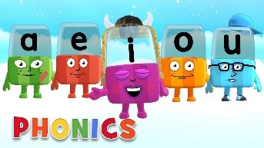
Phonics

Day 3 – Below are the sounds and words that you should know by the end of year 2.

The al sound spelt a before l and ll (all tall fall)
The /u/ sound spelt o (other, mother, brother)
The /o/ sound spelt a after w and qu (quantity, squash, want, watch)
The /ur/ sound spelt or after w (word, work, worm, world)
The /or/ sound spelt ar after w (war, warm, towards)
The /zh/ sound spelt s (treasure, television, pleasure, visual)
Words ending in –tion (station, vacation)
Adding –ed, –ing, –er and –est to a root word ending in –y with a consonant before it.
Adding the endings –ing, –ed, –er, –est and –y to words ending in –e with a consonant before it (hiking, hiked, hiker, nicer, nicest, shiny)
Adding –ing, –ed, –er, –est and –y to words of one syllable ending in a single consonant letter after a single vowel letter (doubling up)

Complete the activity below,

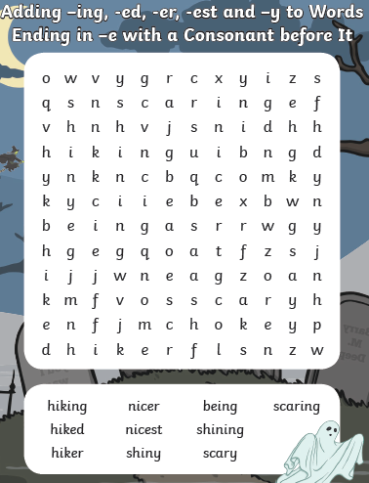
Practise reading and finding the meanings of the words. Can you find any other words with the un or dis prefix?
- Follow this link;
https://www.spellzone.com/curriculum/national-curriculum/year-2.cfm

- Then choose the sound you wish to learn from the orange block, scroll down for more.
- Then select “Spellzone course word list”

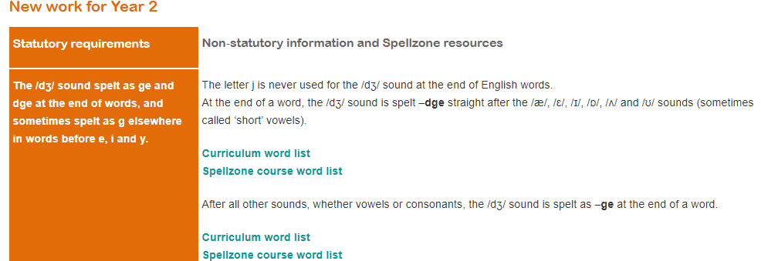
Step 2

Step 3
- You can select the words you wish to hear or an activity from the top

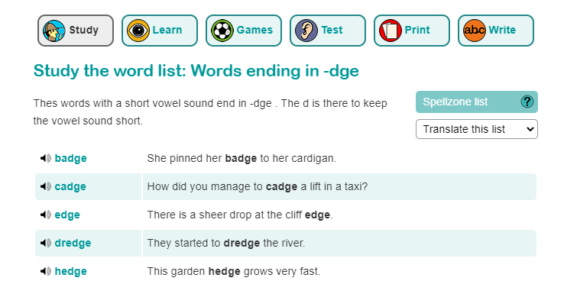
Choose an activity

Or

Hear the words to practise spelling them.
Read a reading book from Bug Club, remember your password is in front of your diary.

Alphablocks is a great website to support with phonics and with how to pronounce the sounds
https://www.bbc.co.uk/cbeebies/shows/alphablocks
Phonics Play has a range of phonics resources and games
www.phonicsplay.co.uk
Spelling frame has lots of games to practice Year 1 and 2 sounds and common exception words.
https://spellingframe.co.uk/
Education City has games and activities for phonics, some may be set or you can choose your own. After an activity you can print your own certificate too.
www.educationcity.com

Topic Day 3

There are 3 great web links to explore.
Check them out and remember to save your favourites to do again and again!
1.

Active kids do better
Description: A range of ideas and resources to inspire families to do some physical activity together
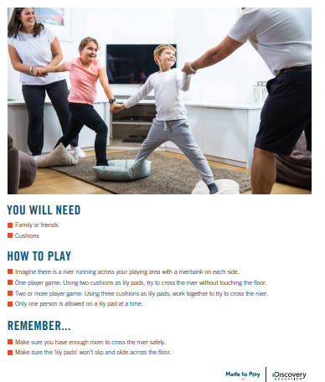
https://www.activekidsdobetter.co.uk/active-home

This looks fun!

2.

National Trust - 50 things to do before you are 11 ¾
Description: A range of ideas to challenge children (if they can get outside)
https://www.nationaltrust.org.uk/50-things-to-do
You could aim for a few things remember you have got at least 4 more years before you are 11 ¾.
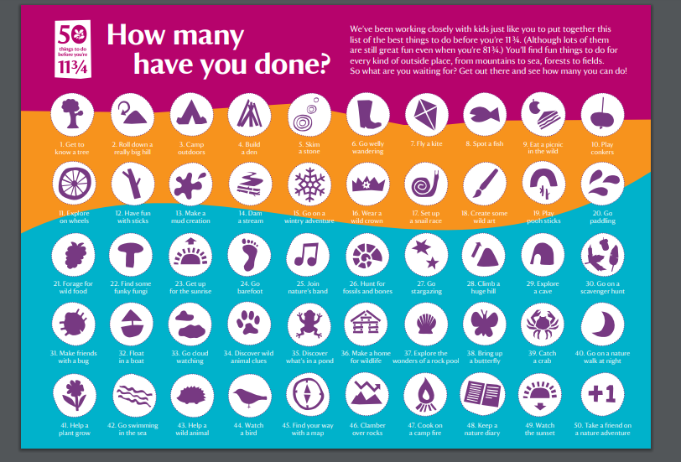

3.

Youth Sport Trust

Description: You can find a range of PE activities that can be done individually or in pairs/small groups with a focus on the development of physical competence and actively learning the importance of personal skills to support social, emotional and mental wellbeing
www.youthsporttrust.org/pe-home-learning
Videos and print outs too!
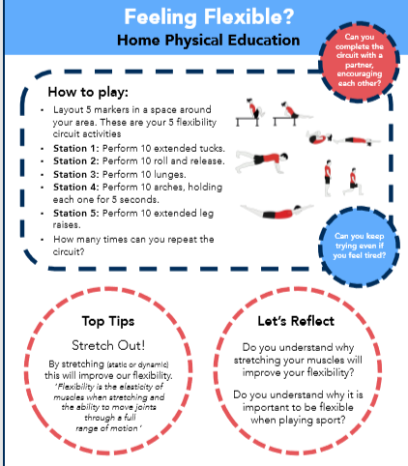
https://www.youtube.com/watch?v=J7ymsKEgKtw&list=PLnwoPgo24bhmqV8Y76iXnwYw9T9AlxbqJ&index=36&t=0s

