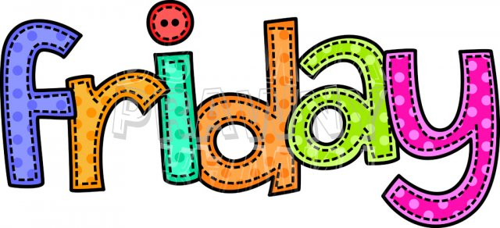

Thank you Year 2! It has been lovely teaching you and seeing you become such amazing characters! Stay safe and we’ll see you soon. Good luck in Year 3!
It has been lovely to see some of you tweeting your work on Twitter. Don’t forget to tag us, so we see your tweet!
https://twitter.com/DevonshireInf
@Devonshireinf @MrFlemingDevInf @devOrangeClass
@devcreamclass @MsSandhuDevInf
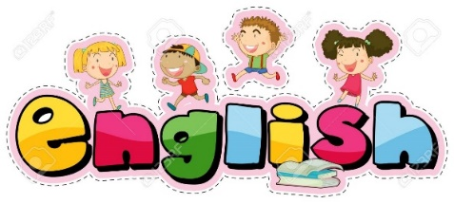

ENGLISH

Follow the link:
https://classroom.thenational.academy/lessons/to-write-a-haiku/activities/1
Today you are going to be writing your own haiku.
After recapping what a haiku is and what you need to make one, you choose and animal:
Once you have done that, you want to think about what they do, making sure you only use 5 syllables for the first line:
Then what they look like. This line has to be 7 syllables. The one after has to be 5 again.

Once your Haiku is finished! Read it to someone out loud!
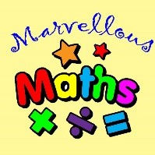

Maths –
Education City
Well done Year Two!
This is the last Maths lesson of the year.
Have a go with the fraction city on your education city login and enjoy trying out old ones too!
Summer Fractions
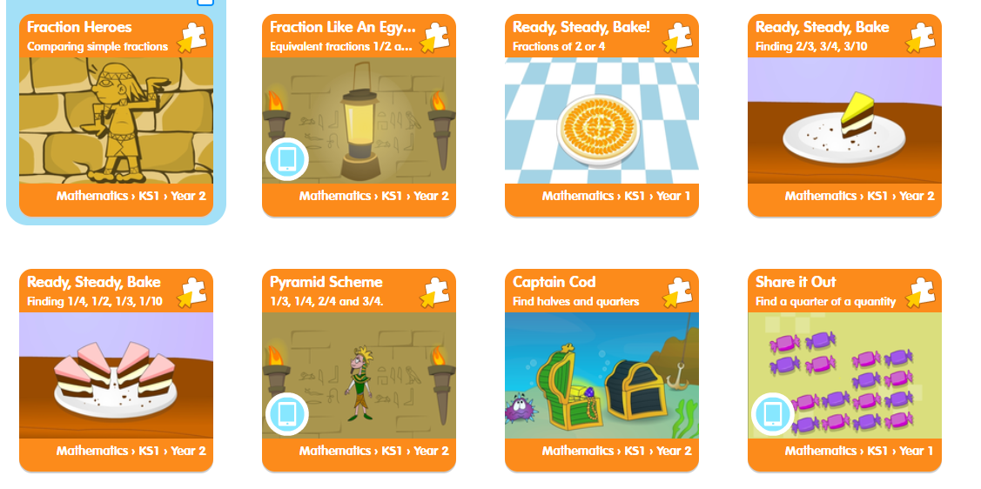

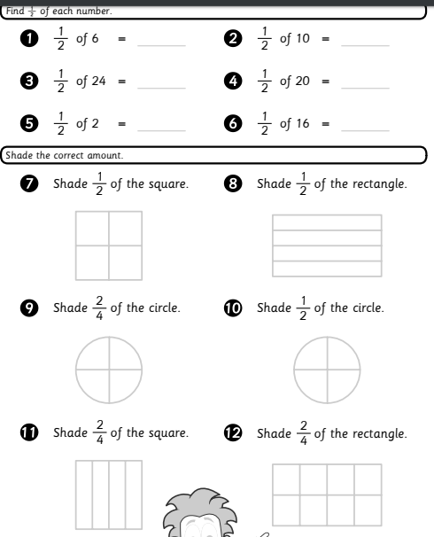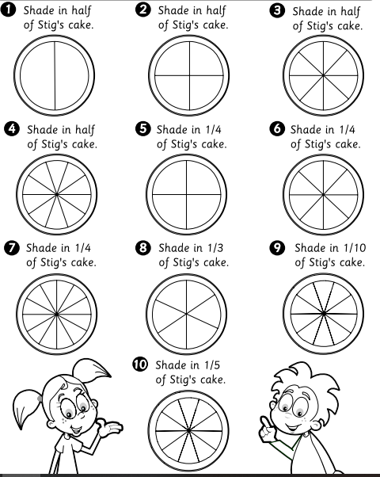
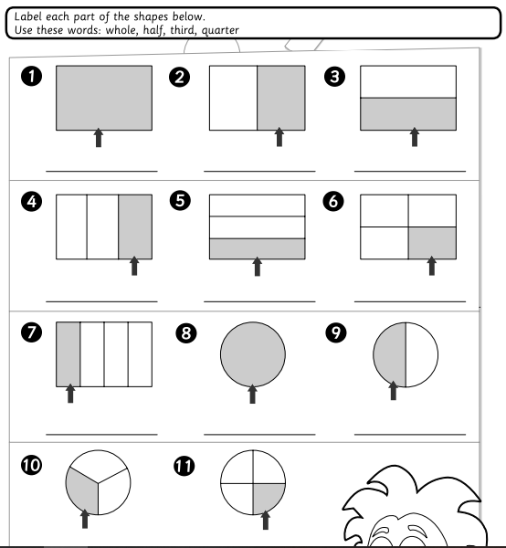
Explore fractions with lego, paper plates (or just regular paper),
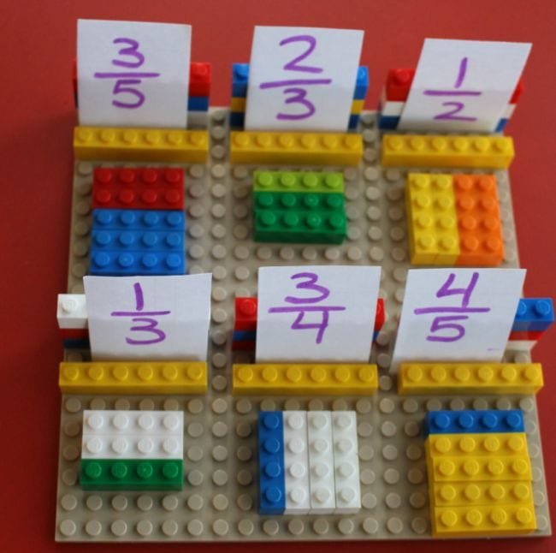

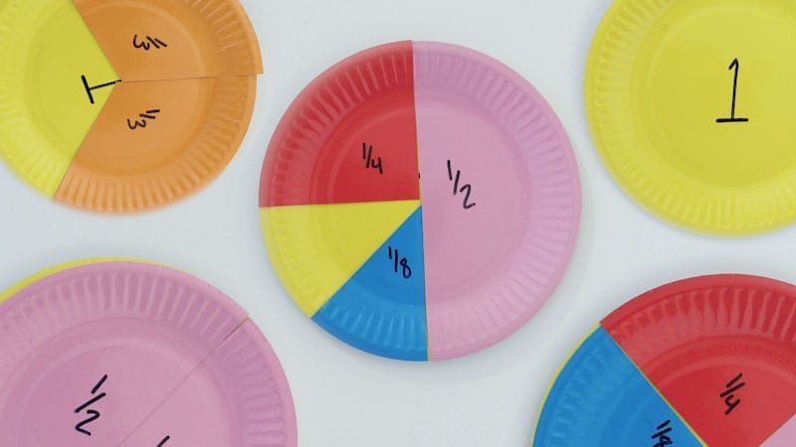

Have a fraction picnic, what better way to learn than with your favourite foods.
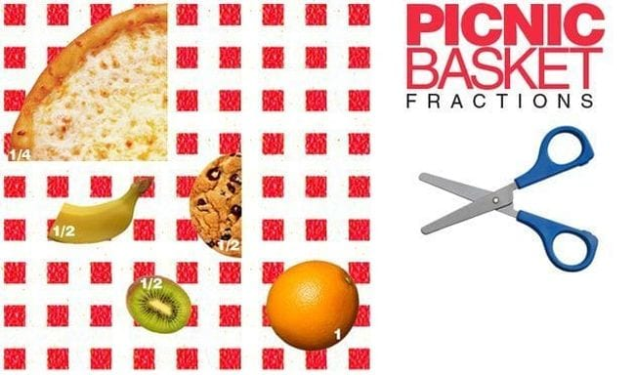
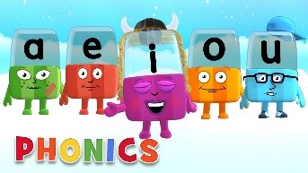

Phonics

Day 5 – Below are the sounds and words that you should know by the end of year 2.

The al sound spelt a before l and ll (all tall fall)
The /u/ sound spelt o (other, mother, brother)
The /o/ sound spelt a after w and qu (quantity, squash, want, watch)
The /ur/ sound spelt or after w (word, work, worm, world)
The /or/ sound spelt ar after w (war, warm, towards)
The /zh/ sound spelt s (treasure, television, pleasure, visual)
Words ending in –tion (station, vacation)
Adding –ed, –ing, –er and –est to a root word ending in –y with a consonant before it.
Adding the endings –ing, –ed, –er, –est and –y to words ending in –e with a consonant before it (hiking, hiked, hiker, nicer, nicest, shiny)
Adding –ing, –ed, –er, –est and –y to words of one syllable ending in a single consonant letter after a single vowel letter (doubling up)

Complete the activity below,
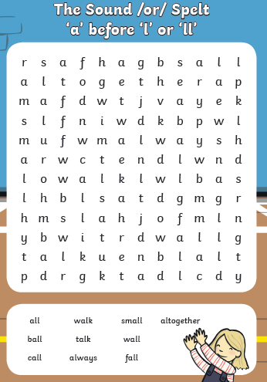
Have a spelling competition using the words you have learnt this week
Then practise reading and spelling 10 common exception words. This can be found on https://spellingframe.co.uk/
Read your reading book – Ask your grown up some questions about your book. Why did the character behave like that? What do you think will happen next?
Write an alternative ending to your book.
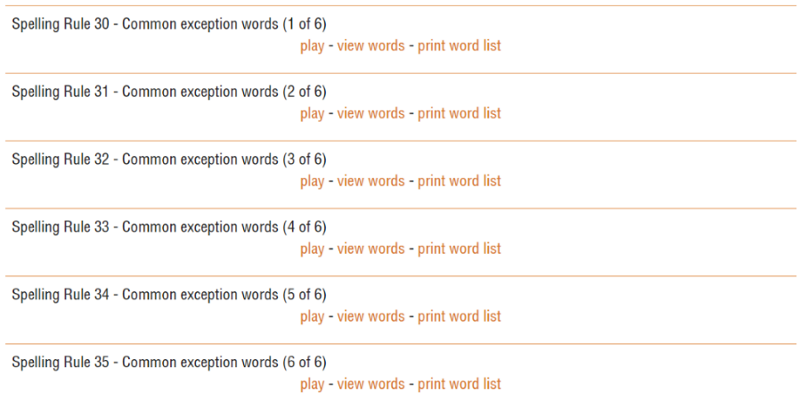

Topic - Day 5

Today there are some great ideas for simple games that need no equipment.
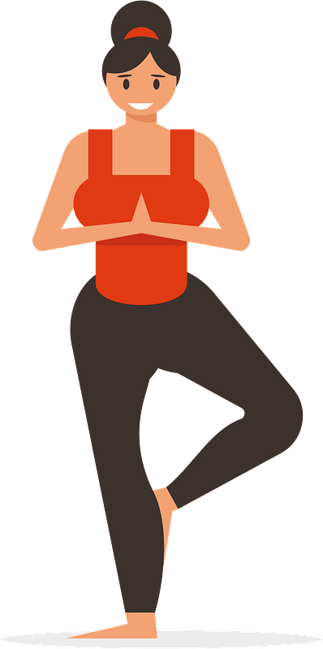

I just love yoga, so I’ve finished this week with ideas from previous weeks to remind you again! Have a chilled relaxing Friday.
Ideas for non contact games

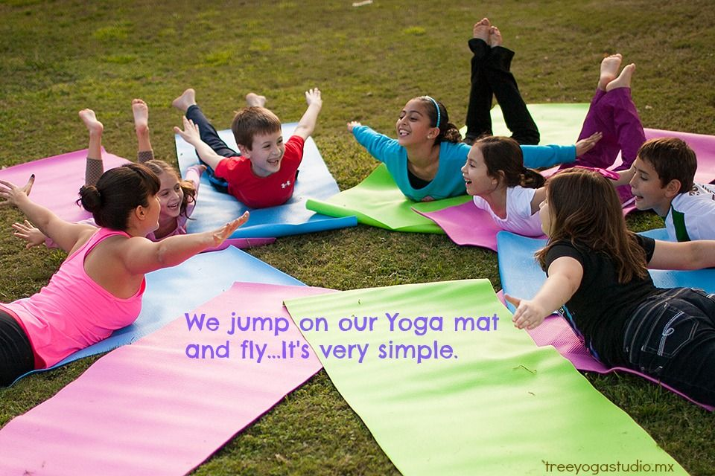

Get moving
When you feel tense, upset, or nervous, muscles in your body tighten. Talk about how your body feels. It can be hard to explain how we feel. This can feel like: a tangled knotting in your tummy, wobbly jelly in your knees. Being stiff like the Tin Man (from The Wizard of Oz): clenching teeth, squeezing fists, holding shoulders stiffly.

The Wizard of Oz (5/8) Movie CLIP - Finding The Tin Man (1939) HD
https://www.youtube.com/watch?v=louBM-Mix7s

By practicing tightening certain muscles in your body, you will learn to relax them.
Now get comfortable. Find a clear space
*Lie on the floor (or sit down with head resting on the table or your knees) and make yourselves feel like ton weights – as heavy as possible. Slowly lift one arm, imagining it to be made of something really heavy – allow it to fall, repeat with the other arm.
*Lift one leg, again as if it were a dead weight – allow it to fall, repeat with the other leg.
*Tense and tighten up every muscle in your face, grimace, clench teeth, feel the skin stretching tight over your face, screw up your eyes, then relax your face completely.
*Tighten your shoulders, then relax. *Tighten your neck, then relax. *Tighten your tummy, then relax.
*Now breathe slowly and deeply by counting ‘in 1, 2, 3, 4’ and ‘out 1, 2, 3, 4’.
Carry on breathing slowly and deeply, establishing your own pattern. Relaxation with slow deep breathing is a good way to help control yourself if you feel tense, angry, worried or anxious.
*Sing with ‘I’m a jingle jangle scarecrow with a flippy-floppy hat’. Do the actions, moving in a flippy-floppy way.
- Dingle Dangle Scarecrow | Kids Action Song with Lyrics | Children Love to Sing
https://www.youtube.com/watch?v=9sIdKVNfoR4
Get moving again
A Relaxing Training Script for Parents to Use with Their Children
When you feel tense, upset, or nervous, muscles in your body tighten. By practicing tightening certain muscles in your body, you will learn to relax them. Now get comfortable!
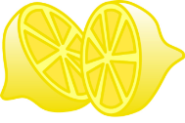 | Hands and Arms: Squeeze a Lemon  Pretend you have a whole lemon in each hand. Now squeeze it hard. Try to squeeze all the juice out! Feel the tightness in your hand and arm as you squeeze. Squeeze hard! Don’t leave a single drop. (Hold for 10 seconds). Now relax and let the lemon drop from your hand. See how much better your hand and arm feel when they are relaxed.
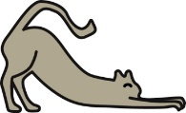 | Arms and Shoulders: Stretch Like a Cat  Pretend you are a furry, lazy cat and you just woke up from a nap. Stretch your arms out in front of you. Now raise them way up high over your head. Feel the pull in your shoulders. Stretch higher and try to touch the ceiling. (Hold for 10 seconds). Great! Let them drop very quickly and feel how good it is to be relaxed. It feels good and warm and lazy.
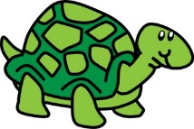 | Shoulders and Neck: Hide in Your Shell  Now pretend you are a turtle. Try to pull your head into your shell. Try to pull your shoulders up to your ears and push your head down into your shoulders. Hold it tight! (Hold for 10 seconds). Okay, you can come out now. Feel your shoulders relax.
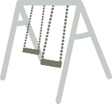 | Back: Swing Up High  Pretend you are on a swing at the park. Swing your upper body back and forth, back and forth. To get really high, use your arms to help you swing! Keep swinging! (Hold for 10 seconds). Great. You’re all done on the swing. Sit back and relax.
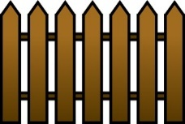 | Stomach: Squeeze Through a Fence  Now pretend that you want to squeeze through a narrow fence. You’ll have to make yourself very skinny if you’re going to make it through. Suck your stomach in, try to squeeze it against your back bone. Get it real small and tight. Hold it as tight as you can! (Hold for 10 seconds). Okay, you’ve made it! You got through the fence. Settle back and let your stomach come back out where it belongs.
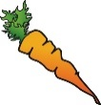 | Jaw: Chew That Carrot  Now, pretend that you are trying to eat a giant, hard carrot. It is very hard to chew. Bite down on it. As hard as you can. We want to turn that carrot into mush! Keep biting. (Hold for 10 seconds). Good. Now relax. You’ve eaten the carrot. Let yourself go as loose as you can.
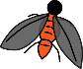 | Face and Nose: Get That Fly Off Your Nose  Here comes a pesky old fly and he has landed on your nose! Try to get him off without using your hands. Wrinkle up your nose. Make as many wrinkles in your nose as you can. Scrunch up your nose real hard and hold it just as tight as you can. Notice that when you scrunch up your nose, your cheeks and your mouth and your forehead and your eyes all help you and they get tight, too. (Hold for 10 seconds). Good. You’ve chased him away. Now you can just relax and let your whole face go smooth.
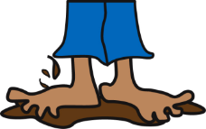 | Legs and Feet: Squish Your Toes in the Mud  Now pretend that you are standing barefoot in a big, fat mud puddle. Squish your toes down deep into the mud. Try to get your feet down to the bottom of the mud puddle. You’ll probably need your legs to help you push. Squish your toes down. Push your feet, hard! (Hold for 10 seconds). Okay, come back out now. Relax your feet, relax your legs, and relax your toes. It feels so good to be relaxed. No tenseness anywhere. You feel warm and tingly.

Yoga
Children get enormous benefits from yoga.
- Physically, it improves their flexibility, strength, coordination, and body awareness.
- It improves their concentration and will create a sense of calmness and relaxation.
- Doing yoga, children exercise, play, giggle and relax, connecting more deeply with their inner self.
- Yoga at an early age encourages self-esteem and body awareness with a physical activity that's non-competitive. Fostering cooperation and compassion.
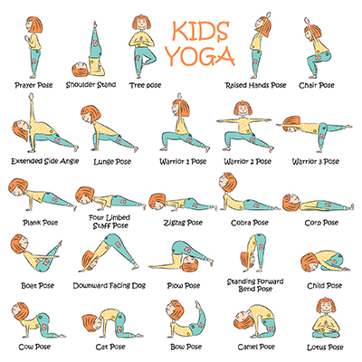

Clear a safe space and everybody can join in. Play some relaxing music. Take your socks off and wear loose comfortable clothes.
Get into poses so you can hold them comfortably without straining or wobbling! Don’t worry about getting the pose “right” just listen to your body. Only hold poses for a few seconds.
You could draw cards of your favourite poses.
You can create a sequence of poses using the cards.

Some cool videos

Yoga for Kids!
Great balloon breathing techniques for relaxation too.
https://www.youtube.com/watch?v=X655B4ISakg

Smile and learn yoga videos

YOGA for Children - Aquatic Animals Yoga Poses - Yoga Practice Tutorial
https://www.youtube.com/watch?v=z2UQ5-cVHjs

Sun Salutations & Yoga with Animals - Yoga for Kids
https://www.youtube.com/watch?v=8oGR5xucItI

Yoga for kids - Yoga animal poses - Yoga practice tutorial - Yoga class for children

https://www.youtube.com/watch?v=s-Z127YfUQo

