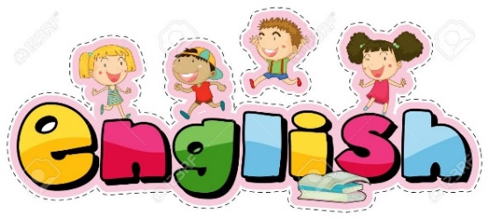

ENGLISH

Follow the link:
https://classroom.thenational.academy/lessons/to-identify-the-key-features-of-an-action-scene/activities/1/
Today you are going to be identifying key features of an action scene.

Then you are going to identify powerful verbs and fronted adverbials in a piece of writing:
Finally, you are going to do the same again, identifying powerful verbs and fronted adverbials. You are going to put them into a table.

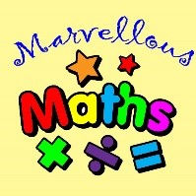
Maths –

Can I subtract from a 2-digit number when an exchange is needed?
In the context of maths, exchanging means trading or swapping one value for an equivalent (equal) amount.
The exchange needs to be fair so the amounts need to be equal.
Click the picture of the ten stick to have a go playing with hundreds tens and ones. If you aren’t able to use the internet then you can make bundles of ten using things from around the house, toothpicks, cotton buds, pencils. Then you can un-bundle them to see how they were made of ten ones.
Mr Palmer apologises for the cringe but watch this video to see how we can subtract with an exchange to help us.
https://youtu.be/hBnPDvg1mCk JOTTINGS
https://youtu.be/ujxg5XOB7G0 EQUIPMENT

Have a go at using jottings to complete these calculations.
Remember – if you don’t have enough ones to subtract then exchange 1 ten for 10 ones. CRUMBLE THAT 10!
31 – 17 = | 24 – 18 = | 42 – 27 =
43 – 29 = | 92 – 48 = | 63 – 46 =
76 – 58 = | 55 – 27 = | 36 – 17 =

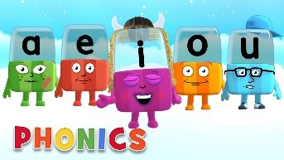
Phonics

Day 4 – This week we will be practising spelling our Common Exception Words. There will be a different set each day.

Complete the activity below.

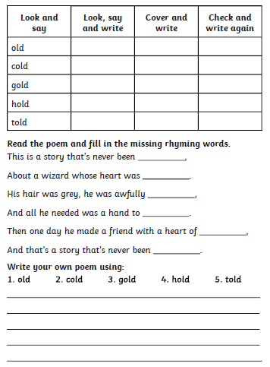
Write sentences using the words above.
For example;
They gold was very shiny.
How cold is it going to get?
Try these quizzes on:
https://www.educationquizzes.com/ks1/english-spelling/year-2-spelling-review-1/
https://www.educationquizzes.com/ks1/english-spelling/year-2-spelling-review-2/
Read a reading book and write questions about the book.
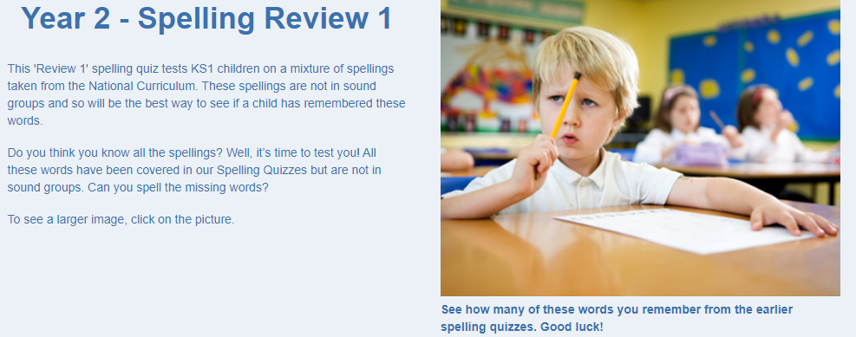
Alphablocks is a great website to support with phonics and with how to pronounce the sounds
https://www.bbc.co.uk/cbeebies/shows/alphablocks
Phonics Play has a range of phonics resources and games
www.phonicsplay.co.uk
Spelling frame has lots of games to practice Year 1 and 2 sounds and common exception words.
https://spellingframe.co.uk/
Education City has games and activities for phonics, some may be set or you can choose your own. After an activity you can print your own certificate too.
www.educationcity.com

Topic - Day 4

Books

There are 20 questions!

Answers at the end of the quiz.

Check out web links at the end of the quiz.
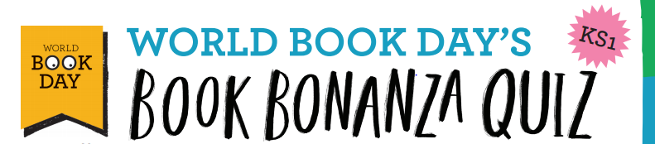

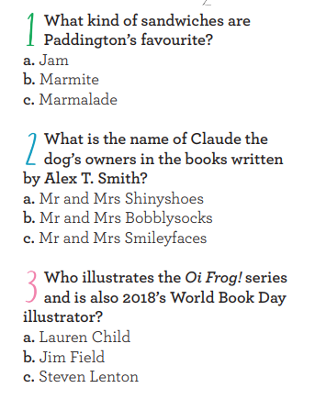

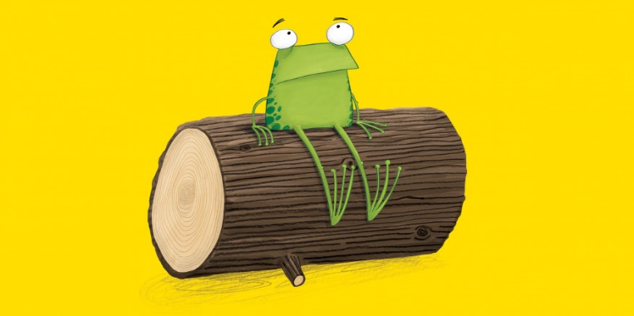

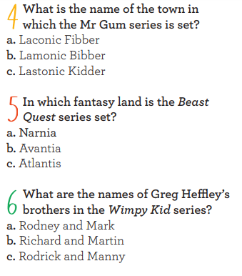

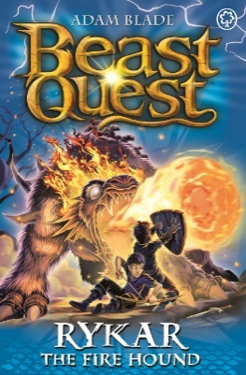

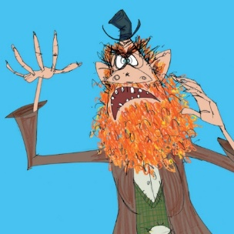
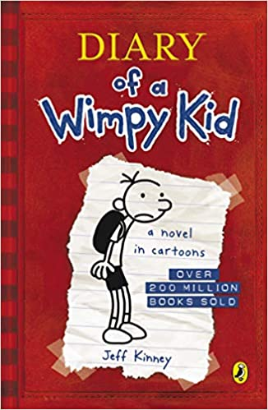

There are lots of super books in this quiz.
Why don’t you try reading them!

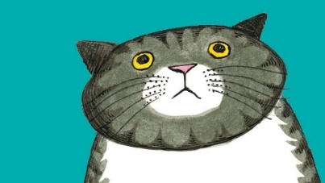
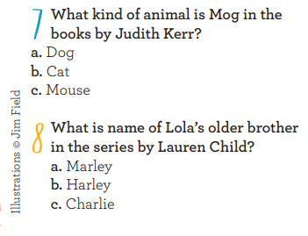

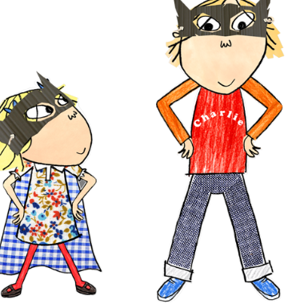

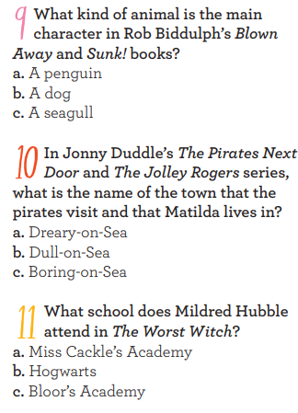
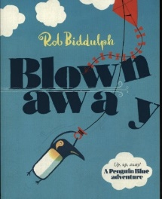

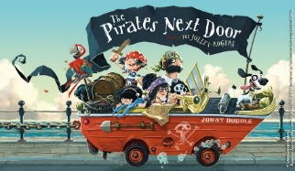

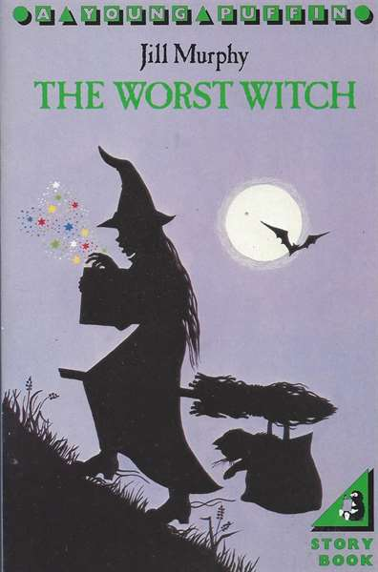

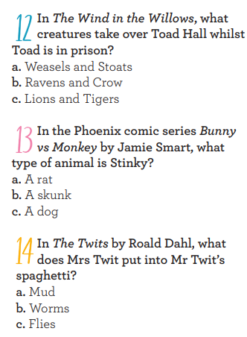
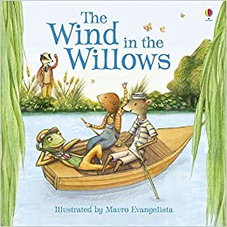

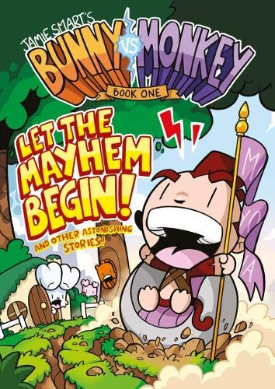

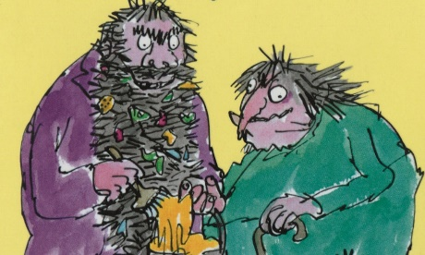

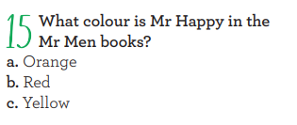

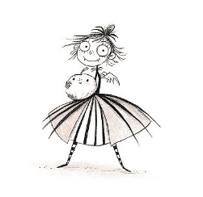
You could make up your own quiz questions about your favourite books!
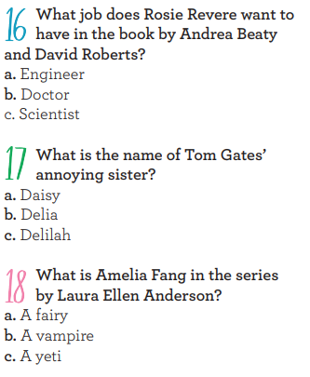

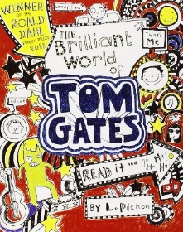

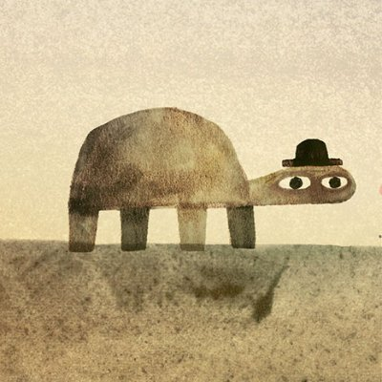
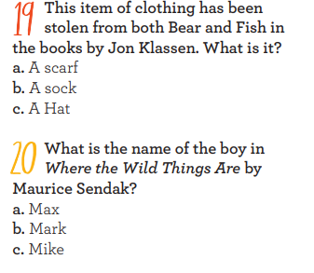

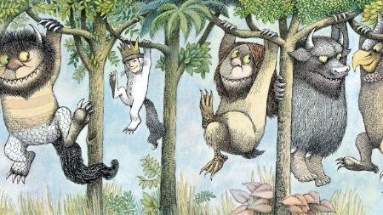

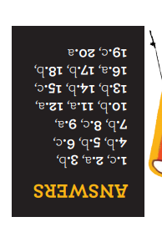

Do you want to find out more about these books? Here are some links so you can hear these super stories. Have fun!

Oi Frog! by Kes Gray - Books Alive! Read Aloud book for kids
https://www.youtube.com/watch?v=2da5yu6rpdg

Review : **** contains fun rhymes.

You're a Bad Man Mr Gum | Bedtime Story
https://www.youtube.com/watch?v=bOsL143jDLA
Review : ***** grossly funny.

Storytime | Mog The Forgetful Cat story by Judith Kerr read aloud by Books Read Aloud For Kids
Review : ***** Mog always gets into trouble but she is adorable.
https://www.youtube.com/watch?v=Nxi2V2402jI

Blown Away by Rob Biddulph

Review : *** A funny story about the perils of kite
https://www.youtube.com/watch?v=Gfyz9kkNB3E
The Pirates Next Door by Jonny Duddle
https://www.youtube.com/watch?v=3LSJWKHoXDw
Review : *** a funny story with a heart-warming message.

Rosie Revere Engineer
by Andrea Beaty
Review : **** great story with cool illustrations
https://www.youtube.com/watch?v=lX9uNOgdp3Q

http://www8.scholastic.co.uk/tomgatesworld/

Review : ***** A cool interactive web page.

Amelia Fang and the Unicorn Lords read by Laura Ellen Anderson
https://www.youtube.com/watch?v=slwn3Q7IXcY
Review : **** Great fun.

THIS IS NOT MY HAT written by Jon Klassen | Read aloud

https://www.youtube.com/watch?v=94xBLFPY124

Review : ***** just such a great story.

Children's book read aloud." WHERE THE WILD THINGS ARE " by Maurice Sendak

Review: ****** A classic story to read and read again wonderful illustrations.

