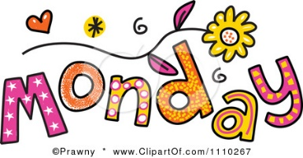

We hope you are enjoying completing the home learning tasks that we are setting for you. It has been lovely to see some of you tweeting your work on Twitter. Don’t forget to tag us, so we see your tweet!
https://twitter.com/DevonshireInf
@Devonshireinf @MrFlemingDevInf @devOrangeClass
@devcreamclass @MsSandhuDevInf

Below are two websites which are providing additional daily lessons.
https://www.thenational.academy/online-classroom/year-1/#subjects

https://www.bbc.co.uk/bitesize
From 20 April, you’ll be able to access regular daily lessons in English and Maths, as well as other core subjects, in an expanded version of BBC bitesize website and also on special programmes broadcast on BBC iPlayer and BBC Red Button
Click on the link above to find out more.

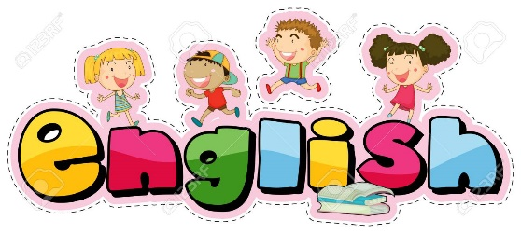

ENGLISH

Hello everybody!

Follow the link:
https://classroom.thenational.academy/lessons/the-firework-makers-daughter-to-find-the-meaning-of-words-161e95/activities/1/
We are continuing with ‘The Firework maker’s Daughter’.
Work through the video. The first part is spellings. You can practise the spellings like we do normally.
Today’s lesson objective is to find meanings of words when reading the text.
This is the order of how you should do it:
Have a go at answering the questions on word meanings.

 | 1 | 2 |  | 3 |  | 4 |  | 5
 | look, say and cover | write and check  |  | write and check  |  | write and check  |  | write and check 
look and  say | Father
 | Class
 | Grass
cover | Pass
 | Plant
 | Path
write | Bath
 | Hour
 | Move
check | Prove

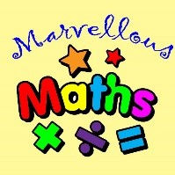
Maths – Money
Warm up
Counting in £5s and then ones.
Write the totals next to the amounts. Remember the £ pound sign.
1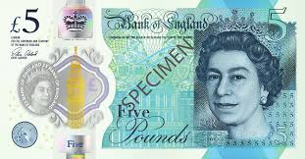
2
3
4
Now look at the value of these other notes.
5. 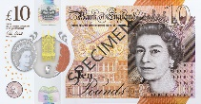
6.
7. 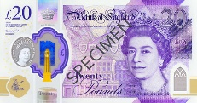
8. 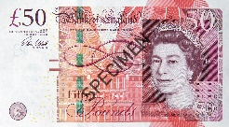

Main
Can I write amounts over £1 using pounds and pence signs?
Remember
One pound and thirty pence = £1.30p = 130p
The little full stop is called a decimal point. Its job is to help you read the price in pounds first, then you can see how many pennies.
Complete this table to help you practise.
Words | Pounds and pence  £ and p | Just p
One pound | £___.___p | 100 p
Three pounds and twenty pence. | £___.___p | 320p
 | £5.27p | ______p
 | £4.99p | 499p
One pound and seventy-five pence | £___.___p | ______p
 | £2.50p | ______p
Use your knowledge of pounds and pennies to help you to order these amounts from smallest to largest.

Order from smallest to largest
- £2.00p 201p 50p 20p £5.00p
_______ _______ _______ _______ ________
- £3.20p 10p 400p 500p £2.00p
_______ _______ _______ _______ ________
- £1.05p 100p 87p 63p £2.20p
_______ _______ _______ _______ ________
- 5p £5.01p 99p 75p 300p
_______ _______ _______ _______ ________
- 60p £1.60p £1.16p £1.30p £1.13p
_______ _______ _______ _______ ________

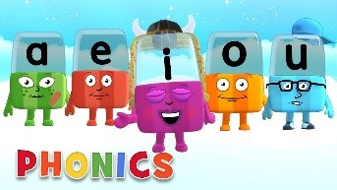
Phonics

Day 1 – This week we are revising the sounds and spelling that you have learnt this year.
Below are the sounds and words that you should know by the end of year 2.

The /j/ sound spelt as ge and dge at the end of words, and sometimes spelt as g elsewhere in words before e, i and y (badge, edge, bridge, dodge, fudge)
The /s/ sound spelt c before e, i and y (race, ice, cell, city, fancy)
The /n/ sound spelt kn and (less often) gn at the beginning of words (knock, know, knee, gnat, gnaw),
The wr sound spelt wr at the beginning of words (write, written, wrap, wrote)
The /l/ or /le/ sound spelt –le at the end of words (table, apple, bottle, little)
The /al/ sound spelt –al at the end of words (metal, pedal, capital, hospital)
The /l/ or el/ sound spelt –el at the end of words (camel, tunnel, squirrel)
Words ending –il (pencil, fossil, nostril)
The /igh/ sound spelt –y at the end of words (cry, fly, dry)

Complete the activity below,

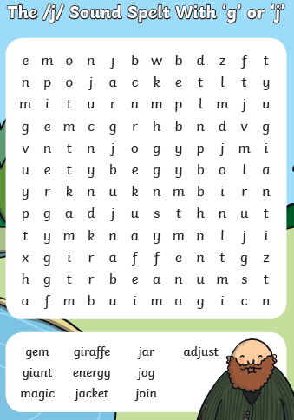
Practise spelling these words. There are lots videos to help you on this site:
https://www.youtube.com/channel/UC4T3jtRh8-7iW_koiRSkglQ/videos
scroll down and find these videos help
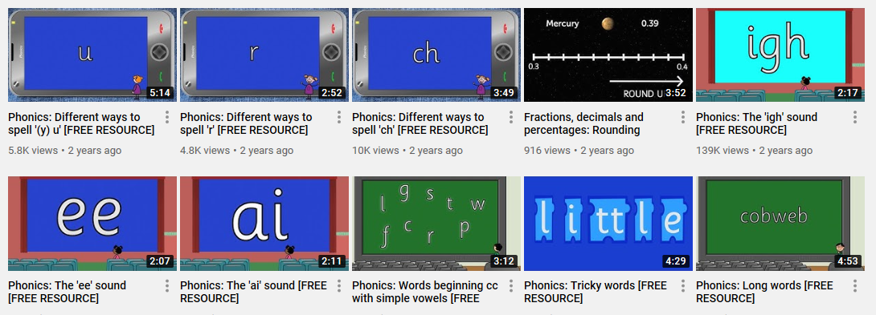
Read your reading book. Ask the questions in the front or the back of the book.
Ask simple questions – Who are the characters in the book? How would you describe the characters? What happened first? Next? At the end? Were there any parts that made you feel a certain way? Why? Does this book remind you of any other stories you know? How would you change the ending?

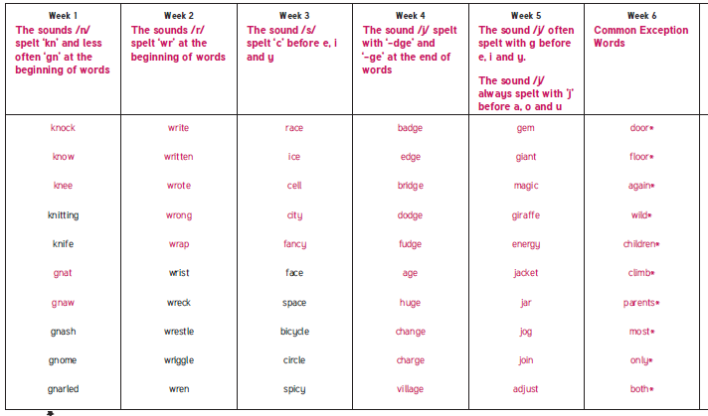
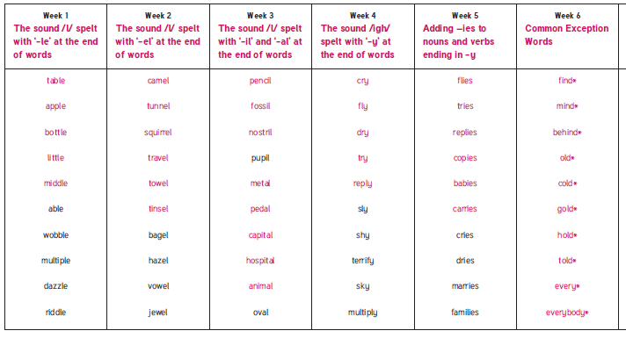

Alphablocks is a great website to support with phonics and with how to pronounce the sounds
https://www.bbc.co.uk/cbeebies/shows/alphablocks
Phonics Play has a range of phonics resources and games
www.phonicsplay.co.uk
Spelling frame has lots of games to practice Year 1 and 2 sounds and common exception words.
https://spellingframe.co.uk/

Education City has games and activities for phonics, some may be set or you can choose your own. After an activity you can print your own certificate too.
www.educationcity.com

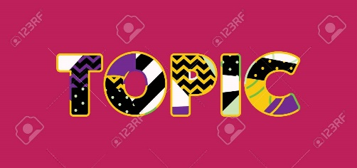
Topic – Day 1

Have fun experimenting with doodles.
Can you copy these patterns?
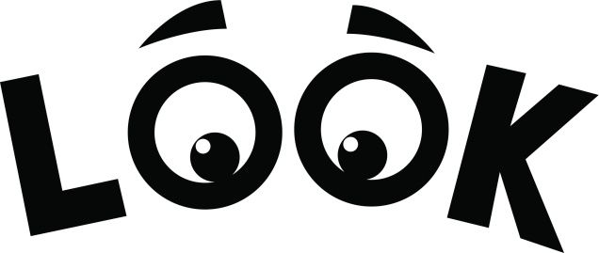 carefully at the lines.
Are they thin or thick?
Are they straight or curved?
What shapes can you notice?
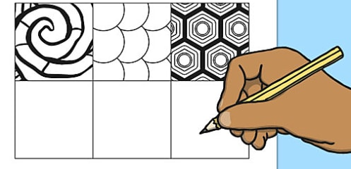

Now try to experimenting and creating your own shapes and patterns.

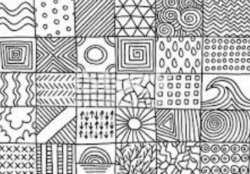

Use all your super patterns and doodles.
Try using some of your ideas in a special design.
Draw an outline of your choice the examples below show ideas a Princess’s dress, a witch’s cloak, a teapot!
Now add your design to make your object beautiful.
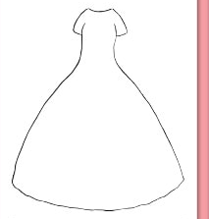
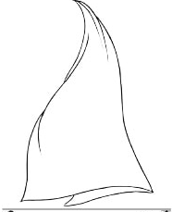
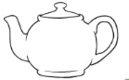

Day 2 Tuesday

